The Music of the Night (Andrew Lloyd Webber / Charles Hart / Richard Stilgoe)
(GCEA)

C G C G
Night time sharpens, heightens each sensation
C G F G
Darkness stirs and wakes imagination
F C F C
Silently the senses abandon their defenses
F Bb F C Dm Em
C G C G
Slowly, gently night unfurls it's splendor
C G F G
Grasp it, sense it, tremulous and tender
F C F C
Turn your face away from the garish light of day
F Bb F C
Turn your thoughts away from cold, unfeeling light
F G7 C
And listen to the music of the night

Bb
Close your eyes and surrender
Eb
To your darkest dreams
Ab D D7
Purge y our thoughts of the life you knew before
G G7 C
Close your eyes, let your spirit start to soar
Em B E7
And you’ll live as you never lived before

C G C G
Softly, deftly, music shall caress you
C G F G
Hear it, feel it, secretly possess you
F C F C
Open up your mind, let your fantasies unwind
F Bb F C
In this darkness which you know you cannot fight
F G7 C
The darkness of the music of the night

Bb Eb
Let your mind start a journey to a strange new world
Ab D D7
Leave all thoughts of the life you knew before
G G7 C
Let your soul take you where you long to be
Em B E7
Only then can you belong to me

C G C G
Floating, falling, sweet intoxication
C G F G
Touch me, trust me, savor each sensation
F C F C
Let the dream begin, let your darker side give in
F Bb F C
To the power of the music that I write
F G7 C
The power of the music of the night
C G C G / C G F G7 / F C F C
F Bb F C
You alone can make my song take flight
F G7 F Dm Dbm B C
Help me make the music of the night

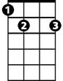
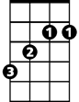
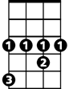
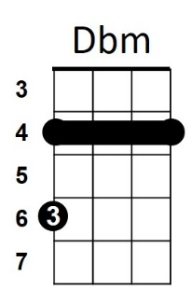

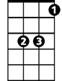


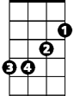
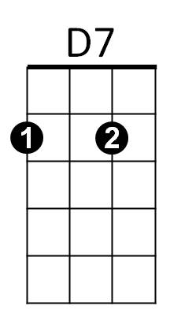




E7
B
Ab
G7
Eb
Bb
F
Em
Dm
D
C
G

The Music of the Night (Andrew Lloyd Webber / Charles Hart / Richard Stilgoe)
BARITONE (DGBE)

C G C G
Night time sharpens, heightens each sensation
C G F G
Darkness stirs and wakes imagination
F C F C
Silently the senses abandon their defenses
F Bb F C Dm Em
C G C G
Slowly, gently night unfurls it's splendor
C G F G
Grasp it, sense it, tremulous and tender
F C F C
Turn your face away from the garish light of day
F Bb F C
Turn your thoughts away from cold, unfeeling light
F G7 C
BARITONE
And listen to the music of the night

Bb
Close your eyes and surrender
Eb
To your darkest dreams
Ab D D7
Purge your thoughts of the life you knew before

G G7 C
Dm
Close your eyes, let your spirit start to soar
Em B E7
And you’ll live as you never lived before

C G C G
Softly, deftly, music shall caress you
C G F G
Hear it, feel it, secretly possess you
F C F C
Open up your mind, let your fantasies unwind
F Bb F C
In this darkness which you know you cannot fight
F G7 C
The darkness of the music of the night

Bb Eb
Let your mind start a journey to a strange new world
Ab D D7
Leave all thoughts of the life you knew before
G G7 C
Let your soul take you where you long to be
Em B E7
Only then can you belong to me

C G C G
Floating, falling, sweet intoxication
C G F G
Touch me, trust me, savor each sensation
F C F C
Let the dream begin, let your darker side give in
F Bb F C
To the power of the music that I write
F G7 C
The power of the music of the night
C G C G / C G F G7 / F C F C
F Bb F C
You alone can make my song take flight
F G7 F Dm Dbm B C
Help me make the music of the night

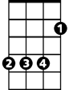
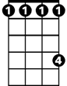

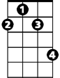
F
B
G
Bb
Ab
Eb
G7
Dbm
C
D


Em

D7

