The Rainbow Connection (Paul Williams / Kenneth Ascher) Key C
Intro: C Csus4 4x

C Am
Why are there so many
Dm G7
Songs about rainbows?
Cmaj7 Am Dm G7
And what's on the other side
C Am Dm G7
Rainbows are visions but only illusions
Cmaj7 Am Dm G7
And rainbows have nothing to hide

F
So we've been told and some choose to believe it
Em7 Gmaj7 Em7
I know they're wrong, wait and see
F G7 Em7 A7
Some day we'll find it, the rainbow connection
Dm G7 C
The lovers, the dreamers, and me
C Csus4 C Csus4

C Am
Who said that every wish
Dm G7
Would be heard and answered
Cmaj7 Am Dm G7
When wished on the morning star
C Am Dm G7
Somebody thought of that and someone believed it
Cmaj7 Am Dm G7

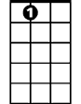
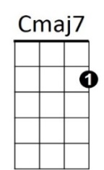
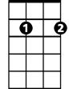
And look what it's done so far
F
A7
Em7

F
What's so amazing that keeps us stargazing?
Em7 Gmaj7 Em7
And what do we think we might see
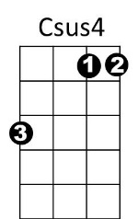


F G7 Em7 A7
Am
C
G7
Some day we'll find it, the rainbow connection
BARITONE
Dm G7 C
The lovers, the dreamers, and me
Em7 Am Cmaj7
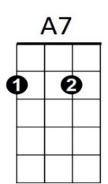
All of us under its spell,
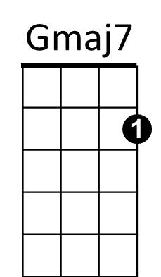
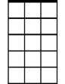

F C Dm G7
Em7
F

We know that it's probably ma - gic
Dm

C Am
Have you been half asleep?
Dm G7
And have you heard voices?
Cmaj7 Am Dm G7
I've heard them calling my name
C Am
Is this the sweet sound
Dm G7
That called the young sailors?
Cmaj7 Am Dm G7
The voice might be one and the same

F
I've heard it too many times to ignore it
Em7 Gmaj7 Em7
It's something that I'm supposed to be

F G7 Em7 A7
Some day we'll find it, the rainbow connection
Dm G7 C
The lovers, the dreamers, and me
Em7 Am Cmaj7
La da da di da da dum
F G7 C
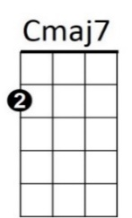
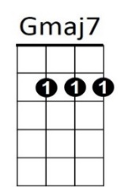
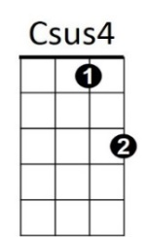



La duh da da dum di da doo
Am
C
Dm
G7

The Rainbow Connection (Paul Williams / Kenneth Ascher) Key F
Intro: F Fsus4 4x

F Dm
Why are there so many
Gm C7
Songs about rainbows?
Fmaj7 Dm Gm C7
And what's on the other side
F Dm Gm C7
Rainbows are visions but only illusions
Fmaj7 Dm Gm C7
And rainbows have nothing to hide

Bb
So we've been told and some choose to believe it
Am7 Cmaj7 Am7
I know they're wrong, wait and see
Bb C7 Am7 D7
Some day we'll find it, the rainbow connection
Gm C7 F
The lovers, the dreamers, and me
F Fsus4 F Fsus4

F Dm
Who said that every wish
Gm C7
Would be heard and answered
Fmaj7 Dm Gm C7
When wished on the morning star
F Dm Gm C7
Somebody thought of that and someone believed it
Fmaj7 Dm Gm C7
And look what it's done so far

Bb
What's so amazing that keeps us stargazing?
Am7 Cmaj7 Am7
And what do we think we might see
Bb C7 Am7 D7
BARITONE
Some day we'll find it, the rainbow connection
F
Gm C7 F
The lovers, the dreamers, and me
Am7 Dm Fmaj7
All of us under its spell,
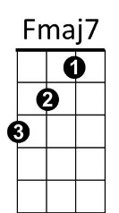
Bb F Gm C7
We know that it's probably ma - gic

F Dm
Have you been half asleep?
Gm C7
And have you heard voices?
Fmaj7 Dm Gm C7
I've heard them calling my name
F Dm
Is this the sweet sound
Gm C7
That called the young sailors?
Fmaj7 Dm Gm C7
The voice might be one and the same

Bb
I've heard it too many times to ignore it
Am7 Cmaj7 Am7
It's something that I'm supposed to be

Bb C7 Am7 D7
Some day we'll find it, the rainbow connection
Gm C7 F
The lovers, the dreamers, and me
Am7 Dm Fmaj7
La da da di da da dum
Bb C7 F
La duh da da dum di da doo
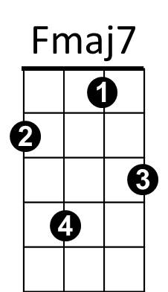
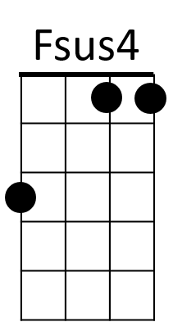
Dm
C7
Gm
F
Em7
Bb
Am7

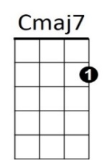

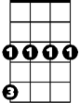
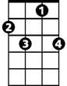
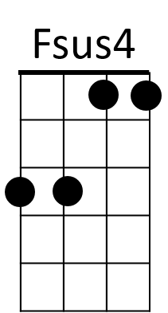
Dm
Gm
C7

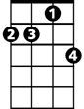
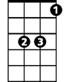
Am7
Bb
Em7

The Rainbow Connection (Paul Williams / Kenneth Ascher) Key G
Intro: G Gsus4 4x

G Em
Why are there so many
Am D7
Songs about rainbows?
Gmaj7 Em Am D7
And what's on the other side
G Em Am D7
Rainbows are visions but only illusions
Gmaj7 Em Am D7
And rainbows have nothing to hide

C
So we've been told and some choose to believe it
Bm7 Dmaj7 Bm7
I know they're wrong, wait and see
C D7 Bm7 E7
Some day we'll find it, the rainbow connection
Am D7 G
The lovers, the dreamers, and me
G Gsus4 G Gsus4

G Em
Who said that every wish
Am D7
Would be heard and answered
Gmaj7 Em Am D7
When wished on the morning star
G Em Am D7
Somebody thought of that and someone believed it
Gmaj7 Em Am D7
And look what it's done so far

C
What's so amazing that keeps us stargazing?
Bm7 Dmaj7 Bm7
And what do we think we might see
C D7 Bm7 E7
BARITONE
Some day we'll find it, the rainbow connection
Am D7 G
The lovers, the dreamers, and me
Bm7 Em Gmaj7
All of us under its spell,
C G Am D7
We know that it's probably ma - gic

G Em
Have you been half asleep?
Am D7
And have you heard voices?
Gmaj7 Em Am D7
I've heard them calling my name
G Em
Is this the sweet sound
Am D7
That called the young sailors?
Gmaj7 Em Am D7
The voice might be one and the same

C
I've heard it too many times to ignore it
Bm7 Dmaj7 Bm7
It's something that I'm supposed to be

C D7 Bm7 E7
Some day we'll find it, the rainbow connection
Am D7 G
The lovers, the dreamers, and me
Bm7 Em Gmaj7
La da da di da da dum
C D7 G
La duh da da dum di da doo
Am
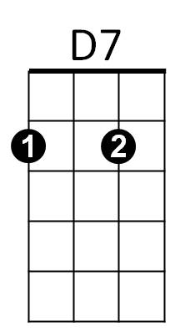
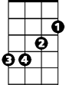
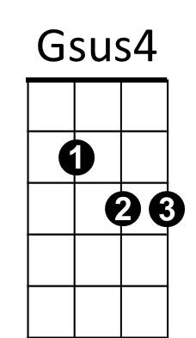

Em
G

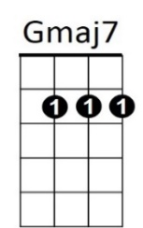
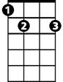
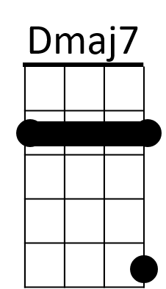
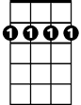
E7
Bm7
C

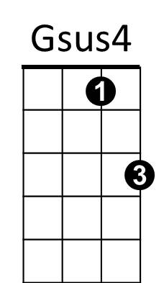
Em
D7
Am
G

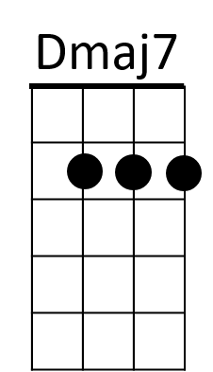
E7
Bm7
C

