The Sadder but Wiser Girl (Meredith Wilson)
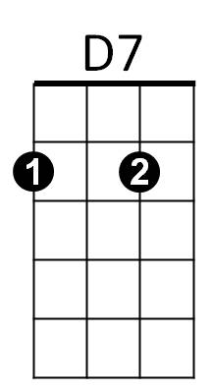


(Spoken)
No wide-eyed, eager, wholesome Innocent Sunday school teacher for me
G
D
That kinda girl spins webs no spider ever -
D/ G/
Listen boy, a girl who trades on all that purity
D/ G/
Merely wants to trade my independence for her security



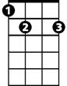
D D7 G G7
C7
Am
E7
The only affirmative she will file, refers to marching down the aisle
C D7
No golden, glorious, gleaming pristine goddess, no sir
E7 Am C7
For no Diana do I play faun, I can tell you that right now
F D7 C A7



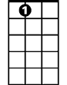

I snarl, I hiss, how can ignorance be compared to bliss?
G7
C
F
A7
Gm
F D7 C A7
I spark, I fizz for the lady who knows what time it is
F D7 C A7
I cheer, I rave for the virtue I'm too late to save
D7 G7 C C Gm C Gm
The sadder but wiser girl for me

C D7
No bright-eyed, blushing, breathless baby-doll baby, no sir
Am G C
That kinda child ties knots no sailor ever knew
E7 Am E7 Am
I prefer to take a chance on a more adult romance
D
BARITONE
No dewy young miss who keeps resisting
E7
D7
D
G
G
All the time she keeps insisting

C D7
No wide-eyed, wholesome, innocent female, no sir
E7 Am C7

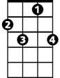

Why, she's the fisherman, I'm the fish, you see? Plop!
F
C7
Am
F D7 C A7
I flinch, I shy when the lass with the delicate air goes by
F D7 C A7
I smile, I grin when the gal with a touch of sin walks in
F D7 C A7
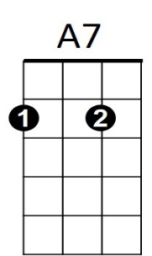
I hope, I pray for Hester to win just one more “A”
C
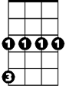
D7 G7 C A7
Gm
G7
The sadder but wiser girl's the girl for me
D7 G7 C
The sad-der but wiser girl for meeeee

