The Things We Do For Love (Eric Stewart / G. Gouldman)
INTRO: G C / Em C / G C Gm7 (last 4 lines of Reprise)
Am F
Too many broken hearts have fallen in the river
C Em Dm
Too many lonely souls have drifted out to sea
F E7
You lay your bets and then you pay the price
Dm C
The things we do for love
F C
The things we do for love

Am F
Communication is the problem to the answer
C Em Dm
You've got her number and your hand is on the phone
F E7
The weather's turned and all the lines are down
Dm C

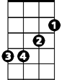

The things we do for love
G
Em
C
F C (break)
The things we do for love

Reprise:
C
Like walking in the rain and the snow
When there's nowh ere to go when you're
Dm C G7
Feeling like a part of you is dying
Am G F
And you're looking for the answer in her eyes
G E7
You think you're gonna break up
Am Fm
Then she says she wants to make up
G C
Ooh you make me love you
BARITONE
Em C
G
Ooh you've got a way
G C
Ooh you had me crawling
Gm7
On the floor (oooh oooh ...)

Instrumental Verse (break)

(Reprise)

Am F
A compromise would surely help the situation
C Em Dm
Agree to disagree but disagree before
F E7
When after all it's just a compromise
Dm C
Of the things we do for love
F C
The things we do for love
Dm C
The things we do for love
F C
The things we do for love
Dm C
The things we do for love
F C
The things we do for love
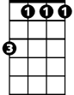
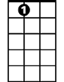



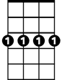


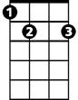
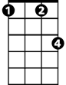
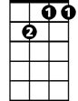
Fm
E7
F
Dm
Am
Gm7
C
Em
F
E7
Dm
Fm
Am
Gm7

