The Wayward Wind (Herbert Newman / Stanley R. Lebowsky) Key C
Intro: C



F
C
C7
Chorus:
C C7 F Fm
The wayward wind is a restless wind
C G7
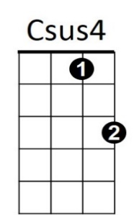
A restless wind that yearns to wander
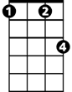

C C7 F Fm
Fm
G7
And he was born - the next of kin
C G7 F C
The next of kin to the wayward wind

C Csus4 C
In a lonely shack by a railroad track
He spent his younger days
Csus4 C
And I guess the sound of the outward-bound
G7 C
Made him a slave to his wand'rin ways
BARITONE

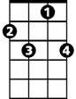
(Chorus)
F
C7
C

C Csus4 C
Oh I met him there in a border town
He vowed we'd never part
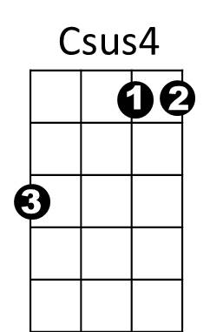
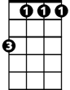
Csus4 C
G7
Fm
Though he tried his best to settle down
G7 C
I'm now alone with a broken heart

(Chorus)

C G7 F C
The next of kin to the wayward wind

The Wayward Wind (Herbert Newman / Stanley R. Lebowsky) Key G
Intro: G


Chorus:
G7
C
G
G G7 C Cm
The wayward wind is a restless wind
G D7
A restless wind that yearns to wander
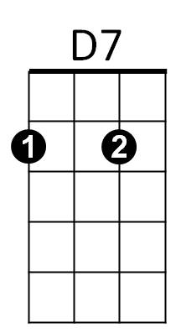
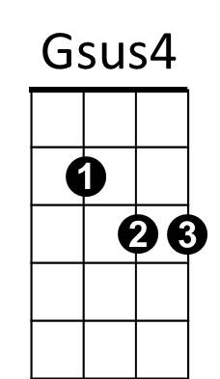
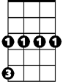
G G7 C Cm
Cm
And he was born - the next of kin
G D7 C G
The next of kin to the wayward wind

G Gsus4 G
In a lonely shack by a railroad track
He spent his younger days
Gsus4 G
And I guess the sound of the outward-bound
D7 G
Made him a slave to his wand'rin ways

(Chorus)

G Gsus4 G
BARITONE
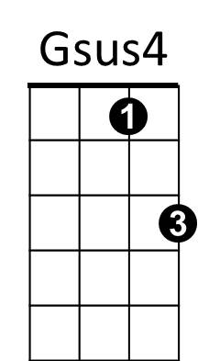
Oh I met him there in a border town
G7
G
Cm
C
He vowed we'd never part
Gsus4 G
Though he tried his best to settle down
D7 G
I'm now alone with a broken heart
D7

(Chorus)

G D7 C G
The next of kin to the wayward wind

