There’s No Place Like Home for the Holidays
C38

C F C




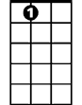

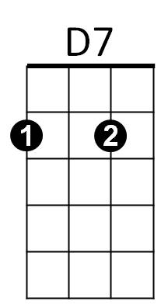
Oh there's no place like home for the holidays.
Dm
G
G7
F
A7
C
A7 D7 G7
Cause no matter how far away you roam,
C F C
When you pine for the sunshine of a friendly gaze,
G7 Dm G7 C F C
For the holi-days you can't beat home, sweet home.

Bridge
F C
I met a man who lives in Tennessee and he was headin' for
G7 C C7
Pennsylvania and some home-made pumpkin pie.
F Dm F C
From Pennsylvania, folks are travelling down to Dixie's sunny shores
G D7 G G7
From Atlantic to Pacific, gee, the traffic is terrific.

C F C
Oh there's no place like home for the holidays.
A7 D7 G7
Cause no matter how far away you roam,
C F C
If you want to be happy in a million ways
G7 Dm G7 C F C
For the holi-days you can't beat home, sweet home.
BARITONE
Repeat From Bridge

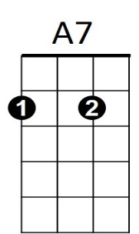

Outro (Retard)
C
F
G7 Dm G7 C F C
For the holi-days you can't beat home, sweet home.



G7
Dm
D7
G

