I'm Thinking Tonight of My Blue Eyes (Ralph Stanley)

Intro: Chords for chorus
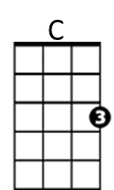
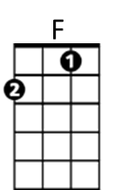
C F
'Twould been better for us both had we never
G G7 C
In this wide, wicked world, had never met
F

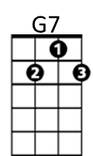
For the pleasure we both seemed to gather
G
G G7 C
I'm sure, love, I'll never forget

Chorus:
C F
Oh, I'm thinking tonight of my blue eyes
G G7 C
Who is sailing far over the sea
F
Oh I'm thinking tonight of him only (Oh, I'm thinking tonight of my blue eyes)*
G G7 C
And I wonder if he ever thinks of me

C F

Oh, you told me once, dear, that you loved me
BARITONE
F

G G7 C
C
You vowed that we never would part
F
But a link in the chain has been broken
G G7 C
Leaving me with a sad and aching heart


G
G7
(Chorus)

C F
When the cold, cold grave shall enclose me
G G7 C
Will you come dear, and shed just one tear
F
And say to the strangers around you
G G7 C
A poor heart you have broken lies here

(Chorus) * Original line used in first recording

