This Masquerade (Leon Russell) Key Am

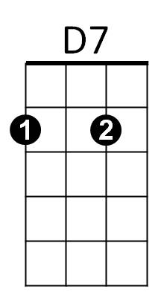
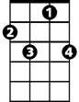
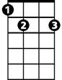
Intro: Am – D7 - F7 - E7 - Am
Am
F7
E7

Am D7
Are we really happy with this lonely game we play?
Am F7 E7
Looking for words to say?
Am D7
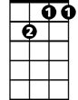

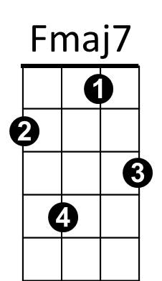

Searching but not finding understanding any way,
Gm7
C7
Dm
F7 E7 Am
We're lost in this masquerade

Bridge:
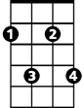
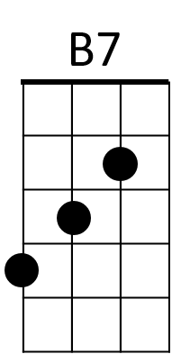

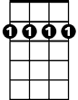
Gm7 C7 Fmaj7 Dm
F#m7
D
Bm7
Both afraid to say we're just too far away,
Gm7 C7 Fmaj7
From being close together from the start
F#m7 B7 E7
We tried to talk it over, but the words got in the way,
D B7 E7 Bm7 E7
We're lost inside this lonely game we play.

Am D7
Thoughts of leaving disappear every time I see your eyes,
Am F7 E7
BARITONE

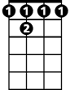
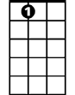
No matter how hard I try
D7
Am
F 7
E7
Am D7
To understand the reason that we carry on this way,
F7 E7 Am
We're lost in this masquerade

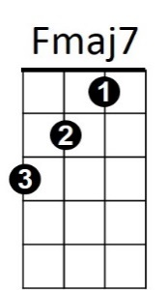
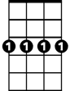

Bridge)
Gm7
C7
Dm

Am
Thoughts of leaving disappear
D7
Every time I see your face,
Am F7 E7

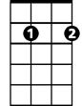
No matter how hard I try
D
B7
Bm7
F#m7
Am D7
We can just start over but it’s oh so hard to do
F7 E7 Am
When you’re lost in a masquerade
F7 E7 Am
When you’re lost in a masquerade

This Masquerade (Leon Russell) Key Dm
Dm
Intro: Dm – G7 - Bb7 - A7 - Dm
A7
Bb7
G7

Dm G7
Are we really happy with this lonely game we play?
Dm Bb7 A7
Looking for words to say?
Dm G7
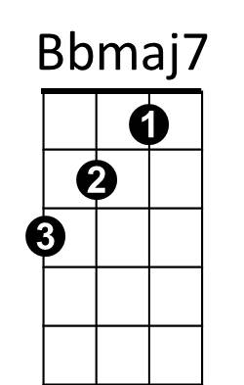
Searching but not finding understanding any way,
Cm7
Gm
F7
Bb7 A7 Dm
We're lost in this masquerade

Bridge:
Cm7 F7 Bbmaj7 Gm
G
E7
Both afraid to say we're just too far away,
Em7
Bm7
Cm7 F7 Bbmaj7
From being close together from the start
Bm7 E7 A7
We tried to talk it over, but the words got in the way,
G E7 A7 Em7 A7
We're lost inside this lonely game we play.

Dm G7
Thoughts of leaving disappear every time I see your eyes,
Dm Bb7 A7
No matter how hard I try
BARITONE
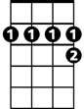
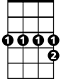
Dm G7
A7
Bb7
G7
Dm
To understand the reason that we carry on this way,
Bb7 A7 Dm
We're lost in this masquerade
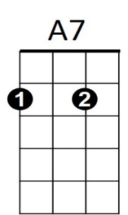
(Bridge)
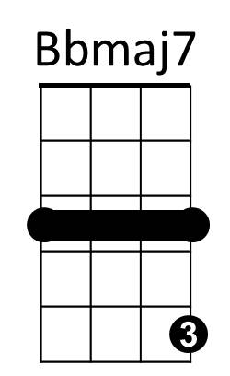
F7
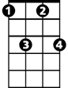
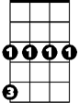
Dm
Cm7
Gm
Thoughts of leaving disappear
G7
Every time I see your face,
Dm Bb7 A7
No matter how hard I try
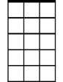

Dm G7
Em7
Bm7
G
E7
We can just start over but it’s oh so hard to do
Bb7 A7 Dm
When you’re lost in a masquerade
Bb7 A7 Dm
When you’re lost in a masquerade

