Those Were the Days (All in the Family) (Lee Adams / Charles Strouse)

F
Boy, the way Glen Miller played.
Dm F
Songs that made the Hit Parade.
Dm A7 G7
Guys like us, we had it made.
C7 F F7
Those were the days

F
Didn't need no welfare state.
Dm F
Everybody pulled his weight
Dm A7 G7
Gee, our old LaSalle ran great.
C7 F F7
Those were the days

Bb
And you knew where you were then
G7 C7 F
Girls were girls and men were men.
Dm
Mist er, we could use a man like
F G7 C C7
Herbert Hoover again.

F
People seemed to be content.
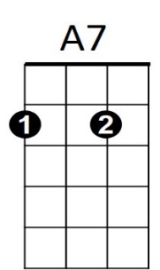


Dm F
F
Dm
BARITONE
Fifty dollars paid the rent.
Dm A7 G7
Freaks were in a circus tent.
C7 F F7
Those were the days
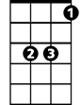

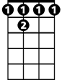
Bb
C
F7
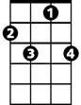
C7

Bb
Take a little Sunday spin,
G7 C7 F
Go to watch the Dodgers win.
Dm
Have yourself a dandy day
F G7 C C7
That cost you under a fin.

F
Hair was short and skirts were long.
Dm F
Kate Smith really sold a song.
Dm A7 G7
I don't know just what went wrong
C7 F



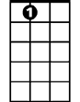

Those were the days
C
C7
F7
Bb
G7
A7
Dm
F
G7

