Ticket To Ride Intro Tabs (C)

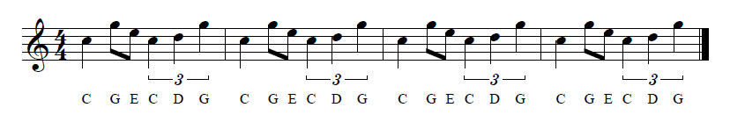
Sequenced in “Noteworthy Composer,” music notation software

C-Tuning
| C G E C D G | C G E C D G | C G E C D G | C G E C D G |
A |-------------|-------------|-------------|-------------|
E |---3-0-----3-|---3-0-----3-|---3-0-----3-|---3-0-----3-|
C |-0-----0-2---|-0-----0-2---|-0-----0-2---|-0-----0-2---|
G |-------------|-------------|-------------|-------------|

0 0 3 0
0 2 3 0

G-Tuning
| C G E C D G | C G E C D G | C G E C D G | C G E C D G |
E |---3-0-----3-|---3-0-----3-|---3-0-----3-|---3-0-----3-|
B |-1-----1-3---|-1-----1-3---|-1-----1-3---|-1-----1-3---|
G |-------------|-------------|-------------|-------------|
D |-------------|-------------|-------------|-------------|

0 0 1 3
0 0 3 3

C-Tuning
| C G E C D G | C G E C D G |
A |-------------|-------------|
E |---3-0-----3-|---3-0-----3-|
C |-0-----0-2---|-0-----0-2---|
G |-------------|-------------|

0 0 3 0
0 2 3 0

G-Tuning
| C G E C D G | C G E C D G |
E |---3-0-----3-|---3-0-----3-|
B |-1-----1-3---|-1-----1-3---|
G |-------------|-------------|
D |-------------|-------------|

0 0 1 3
0 0 3 3

Ticket To Ride Intro Tabs (G)

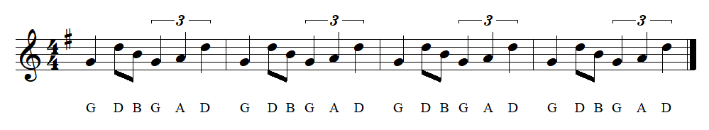
Sequenced in “Noteworthy Composer,”
music notation software that
I’ve used for some years.

C-Tuning
| G D B G A D | G D B G A D | G D B G A D | G D B G A D |
A |-------------|-------------|-------------|-------------|
E |-------------|-------------|-------------|-------------|
C |---2-------2-|---2-------2-|---2-------2-|---2-------2-|
G |-0---4-0-2---|-0---4-0-2---|-0---4-0-2---|-0---4-0-2---|

G-Tuning
| G D B G A D | G D B G A D | G D B G A D | G D B G A D |
E |-------------|-------------|-------------|-------------|
B |-------------|-------------|-------------|-------------|
G |-------------|-------------|-------------|-------------|
D |-------------|-------------|-------------|-------------|

