Ticket To Ride Intro Tabs (C)

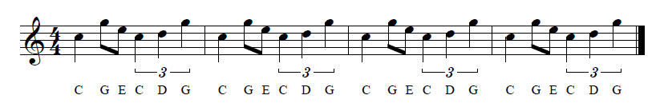
Sequenced in “Noteworthy Composer,” music notation software

C-Tuning
| C G E C D G | C G E C D G | C G E C D G | C G E C D G |
A |-------------|-------------|-------------|-------------|
E |---3-0-----3-|---3-0-----3-|---3-0-----3-|---3-0-----3-|
C |-0-----0-2---|-0-----0-2---|-0-----0-2---|-0-----0-2---|
G |-------------|-------------|-------------|-------------|

0 0 3 0
0 2 3 0

G-Tuning
| C G E C D G | C G E C D G | C G E C D G | C G E C D G |
E |---3-0-----3-|---3-0-----3-|---3-0-----3-|---3-0-----3-|
B |-1-----1-3---|-1-----1-3---|-1-----1-3---|-1-----1-3---|
G |-------------|-------------|-------------|-------------|
D |-------------|-------------|-------------|-------------|

0 0 1 3
0 0 3 3

