


Ticket to Ride (John Lennon / Paul McCartney)
Dm
C7
C

C Csus C
I think I'm gonna be sad, I think it's today, yeah - h
C7 Dm G
The girl that's driving me mad is going away
Am F Am Bbmaj7
She's got a ticket t o ride she's got a ticket to ri-i-de



Am Gm C
Am
G
F
She's g ot a ticket to ride, and she don't care.

C Csus C
She says that living with me is bringing her dow - n
C7 Dm G
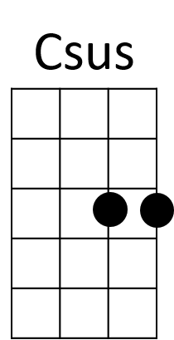
But she will never be free when I was around
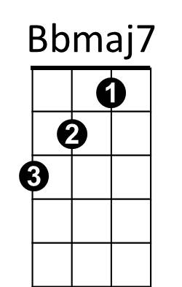

Am F Am Bbmaj7
Gm
She's got a ticket to ride, s he's got a ticket to ri-i-de
Am Gm C
She's got a ticket to ride, and she don't care.

Refrain:
F
I don't know why she's riding so high
G
She ought to think twice, she ought to do right by me
F
Before she gets to saying goodbye
G
She ought to think twice, she ought to do right by me
BARITONE
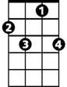

C
Dm
C7
Am
G
F
C Csus C
She says that living with me is bringing her dow - n
C7 Dm G
But she will never be free when I was around
Am F Am Bbmaj7
She's got a ticket to ride she's got a ticket to ri-i-de
Am Gm C
She's got a ticket to ride and she don't care.

(Refrain)

C Csus C
She says that living with me is bringing her dow - n
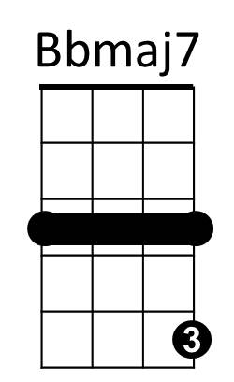
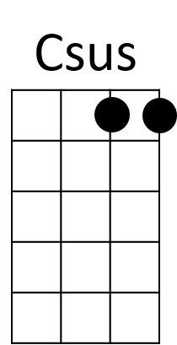
C7 Dm G
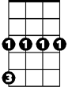
But she will never be free when I was around
Gm
Am F Am Bbmaj7
She's got a ticket to ride she's got a ticket to ri-i-de
Am Gm C
She's got a ticket to ride and she don't care.
TACET C
My baby don’t care. My baby don’t care, my baby don’t care

