Time Warp (Richard O'Brien)

A B
It’s astounding, time is fleeting
G D A
Madness takes its toll
A B
But listen closely, not for very much longer
G D A
I’ve got to - keep control
B
I can remember doing the Time Warp
G D A
Drinking those moments when
A
The blackness would hit me
B
And the void would be call-ing
F C G D A
Let’s do the Time Warp again
F C G D A
Let’s do the Time Warp again

Chorus:
TACET E7
It’s just a jump to the left
A
And then a step to the right
TACET E7
With your hands on your hips
A
You bring your knees in tight
D
But it’s the pelvic thru-st
A
That really drives you in-sa-a-a-a-ne
F C G D A
Let’s do the Time Warp again
F C G D A
Let’s do the Time Warp again
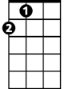
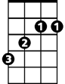


A
B
G
D

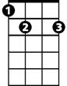


E7
F
C

A B
It’s so dreamy, oh fantasy free me
G D A
So you can’t see me, no, not at all
A B
In another dimension, with voyeuristic intention
G D A
Well secluded, I see all
B
With a bit of a mind flip, you’re into the time slip
G D A
And nothing can ever be the same

You’re spaced out on sensation,
B
Like you’re under se-da-tion
F C G D A
Let’s do the Time Warp again
F C G D A
Let’s do the Time Warp again

A
Well I was walking down the street just having a think

When a snake of a guy gave me an evil wink
D
He shook me up, he took me by surprise
A
He had a pickup truck and the devil’s eyes
E7 D
He stared at me and I felt a change
A
Time meant nothing, never would again
F C G D A
Let’s do the Time Warp again
F C G D A
Let’s do the Time Warp again

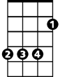

(Chorus)
B
G
A
F
BARITONE
D
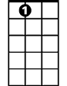
C
E7

