Tonight You Belong To Me (Billy Rose / Lee David)
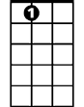
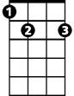

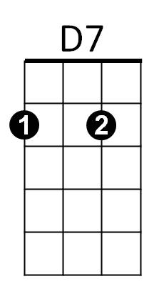

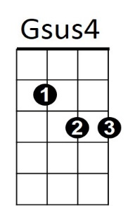

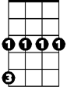

Intro: G Gsus4 G 2x
A7
E7
D
C
G
Cm
G7

G G7
I know - I know- you beloooooong
C Cm
To sooooome-body neeeeeew
G D G
But tonight, you belong to me

G Gsus4 G 2x

G G7
Although -although- we're apaaaaaart
C Cm
You're a paaaaart of my heaaaaart
G D G G7
And tonight, you belong to me

Reprise:
Cm
Way down by the stream, how sweet it will seem
G E7 A7
Once more just to dream in the moonlight
D7
My honey -

G G7
I know -I know- With the daaaaaawn
C Cm
That yo-u will be goooooone
G D G
But tonight, you belong to me
D7 G G Gsus4 G
Just little old me


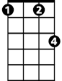
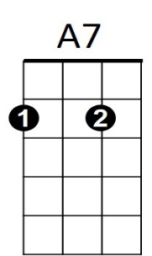
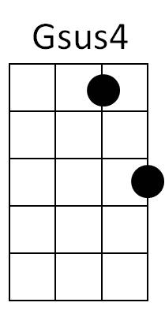
G
D7
C
BARITONE
G7
Cm
D
E7

