Toora Loora Looral (Irish Lullaby) (James Royce Shannon, 1913)
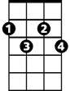
F#dim
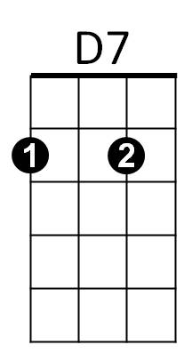



CHORUS:
C7
F
C
C F C C7
Too ra loo ra loo ral
F F#dim
Too ra loo ra ly
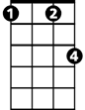



C F C
Fm
G7
Dm
Am
Too ra loo ra loo ral
D7 G7
Hush now don't you cry
C F C C7
Too ra loo ra loo ral
F F#dim

Too ra loo ra ly
BARITONE
F
C
C F C
Too ra loo ra loo ral
D7 Fm C
That's an Irish lul – la - by

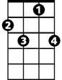
C F C Am C G7
C7
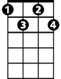
Over in Killarney, many years ago
Fdim
C F C D7 Dm G7
My mother sang a song to me in tones so sweet and low
C F C Am C
Just a simple little ditty in her good old Irish way
F C Am D7 Dm G7
G7
D7
And I'd give the world if she could sing that song to me today

(CHORUS)

C F C Am C G7
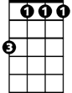
Oft' in dreams I wander to that cot again
Am
Fm
C F C D7 Dm G7
I feel her arms a-huggin' me as when she did back then
C F C Am C
I hear her softly hummin' to me as in days of yore
F C Am D7 Dm G7

When she used to rock me fast asleep outside that cottage door
Dm

(CHORUS)

