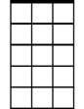




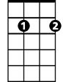
Try To Remember (Tom Jones, Harvey Schmidt, 1960) – Key of C
Am7
Am
Dm
C
G7
Em7
Intro: C Am Dm G7

C Am Dm G7
Try to remember the kind of September
C Am Dm G7
When life was slow and oh, so mellow.

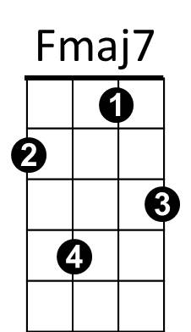
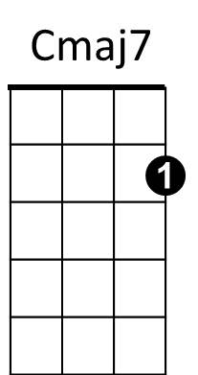
C Am Dm G7
Bb
Try to remember the kind of September
C Am Dm G7
When grass was green and grain was yellow.
Em7 Am7 Dm7 G7
Try to remember the kind of September,
Cmaj7 Fmaj7 Bb G7
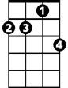
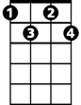
When you were a tender and callow fellow.
Dm7
Fdim
C Am Dm G7 C Am Fmaj7 G7
Try to remember, and if you remember, then follow.

C Am Dm G7
Try to re member when life was so tender,
C Am Dm G7
That no one wept except the willow.
BARITONE

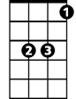
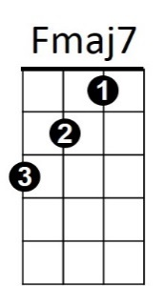
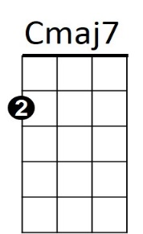


C Am Dm G7
G7
Bb
Am7
Em7
Dm
C
Am
Try to remember when life was so tender,
C Am Dm G7
That dreams were kept beside your pillow.
Em7 Am7 Dm7 G7
Try to remember when life was so tender,
Cmaj7 Fmaj7 Bb G7
That love was an ember about to billow.
C Am Dm G7 C Am Fmaj7 G7
Try to remember, and if you remember, then follow.

C Am Dm G7
Deep in December, it's nice to remember,
C Am Dm G7
Although you know the snow will follow.
C Am Dm G7
Deep in December, it's nice to remember,
C Am Dm G7
Without a hurt the heart is hollow.
Em7 Am7 Dm7 G7
Deep in December, it's nice to remember,
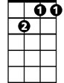
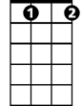
Cmaj7 Fmaj7 Bb G7
Dm7
Fdim
The fire of September that makes us mellow.
C Am Dm G7 C Am Fmaj7 Fdim C
Try to remember, and if you remember, then follow.

Try To Remember (Tom Jones, Harvey Schmidt, 1960) - Key of G

Try to Remember by The Brothers Four (1965)
G
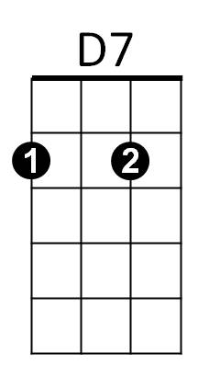
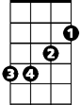
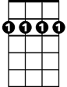
Em
Am
Bm7
Intro: G Em Am D7

G Em Am D7
Try to remember the kind of September
G Em Am D7
When life was slow and oh, so mellow.
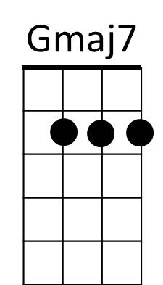
G Em Am D7
Am7
Em7
Try to remember the kind of September
G Em Am D7
When grass was green and grain was yellow.
Bm7 Em7 Am7 D7
Try to remember the kind of September,
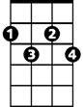
Gmaj7 Cmaj7 F D7
F
Cdim
When you were a tender and callow fellow.
G Em Am D7 G Em Cmaj7 D7
Try to remember, and if you remember, then follow.

G Em Am D7
Try to remember when life was so tender,
G Em Am D7
That no one wept except the willow.
BARITONE
G Em Am D7
G
Em
Am
Try to remember when life was so tender,
G Em Am D7
That dreams were kept beside your pillow.
Bm7 Em7 Am7 D7
Try to remember when life was so tender,
Gmaj7 Cmaj7 F D7
That love was an ember about to billow.
Bm7
D7
G Em Am D7 G Em Cmaj7 D7
Try to remember, and if you remember, then follow.

G Em Am D7
Deep in December, it's nice to remember,
G Em Am D7
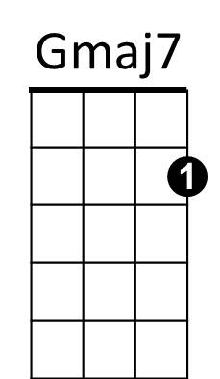
Although you know the snow will follow.
Em7
Am7
G Em Am D7
Deep in December, it's nice to remember,
G Em Am D7
Without a hurt the heart is hollow.
Bm7 Em7 Am7 D7
Deep in December, it's nice to remember,
Gmaj7 Cmaj7 F D7
F
Cdim
The fire of September that makes us mellow.
G Em Am D7 G Em Cmaj7 Cdim G
Try to remember, and if you remember, then follow.

