Twilight Zone (Golden Earring)

Dm
It's two AM and the fear is gone
Gm
I'm sittin' here waiting - the gun's still warm
Am
Thinking my connection is tired
Dm
of taking chances
Dm
Yeah, there's a storm on the loose,
Sirens in my head
Gm
Wrapped up in silence, all circuits are dead
Am
Cannot decode –
Dm
My whole life spins into a frenzy

Chorus:
Dm
Help, I'm stepping into the Twilight Zone
C
The place is a mad-house,
Feels like being cloned
G
My beacon's been moved under moon and star
A A7
Where am I to go now that I've gone too far?
Dm
Help, I'm stepping into the Twilight Zone
C
The place is a mad-house,
Feels like being cloned
G
My beacon's been moved under moon and star
A A7
Where am I to go now that I've gone too far?
G Gm
Soon you will come to know
Dm
When the bullet hits the bone
G Gm
Soon you will come to know
Dm
When the bullet hits the bone

Dm
I'm fallin' down a spiral, destination unknown
Gm
A double-cross messenger, all alone
Am
Can't get no connection - can't get through,
Dm
where are you?
Dm
Well the night weighs heavy on his guilty mind
Gm
This far from the border line
Am
And when the hitman comes
Dm
He knows damn well he has been cheated
And he says:

(Chorus)
Gm Dm (Repeat to fade)




When the bullet hits the bone
C
Dm
Gm
Am


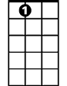
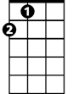
G
A7
A

BARITONE
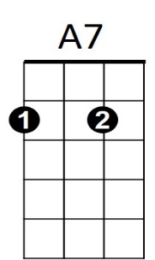
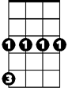

G
Am
Dm
Gm
C


A

