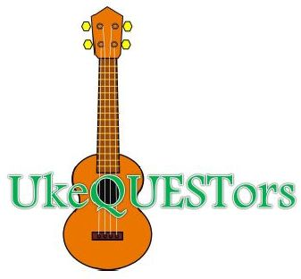
UkeQuestors Jam Special Interest Group (SIG)

Every Sunday from 2:00 to 3:30 pm in the Second Floor Events Room
Huntsville/Madison County Public Library, 915 Monroe St SW, Huntsville, Ala.
If the library is closed for any reason, our Jam is canceled for that day.

2021 Calendar Highlights
All dates subject to change; check our Facebook page

September 5 No Meeting (Labor Day, Mon, Sept. 6)

September 25 Alabama Ukulele Festival performance

September 26 No Meeting

November 28 No Meeting (Thanksgiving, Thu, Nov. 25)

December 26 No Meeting (Christmas Day, Fri, Dec. 24)

January 3 No Meeting (New Year's Day, Fri, Dec. 31)

