

Special Interest Group (SIG)
SONGBOOK
First Edition

Songlist
Title | Event | Page
Bye, Bye, Love | AUF18
Did She Mention My Name
Let Me Be There | AUF18
Let the Love Flow | AUF18
Love Will Keep Us Alive
Save the Last Dance for Me | AUF18
Sloop John B | AUF18
Last Thing on My Mind | AUF18
When I’m 64
Solitary Man
Another Saturday Night
Will the Circle Be Unbroken
My Girl
Ring of Fire
Blowing in the Wind | LQ Mtg
This Land is Your Land | LQ Mtg
Tiny Bubbles | LQ Mtg/ RCUF 1
You Are My Sunshine | LQ Mtg
Hey Good Looking | RCUF 1
Five Foot Two | RCUF 1
I’d Like to Teach the World to Sing | RCUF 1
Jamaica Farewell | RCUF 1
Under the Boardwalk | RCUF 1

Bye Bye Love
Intro: Chords for last line of chorus, 2x



Chorus:
F
C

F C F C F
Bye, bye, love, bye, bye, happiness,
C G7 C


Hello loneliness, I think I'm gonna cry
G7
C7
F C F C F
Bye, bye, love, bye, bye, sweet caress,
C G7 C
Hello emptiness, I feel like I could die,
G7 C
Bye, bye, my love, bye, bye

C G7 C
There goes my baby with someone new
C G7 C C7
She sure looks happy, I sure am blue
F G7
She was my baby, ‘til he stepped in
C F C
Goodbye to romance, that might have been

(CHORUS)
BARITONE

F
C
C G7 C
I'm through with romance, I'm through with love
C G7 C C7
I'm through with counting, the stars a----bove
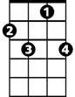
F G7
G7
C7
And here's the reason, that I'm so free
C F C
My loving baby, is through with me

(CHORUS) Repeat last line to end

Did She Mention My Name (Gordon Lightfoot)


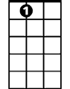
G
C
Am
A7
G C Am
It's so nice to meet an old friend, and pass the time of day,
D D7 G
And talk about the hometown, a million miles away,
C Am
Is the ice still in the river, are the old folks still the same,

D G
D
And by the way, did she mention my name?

C D G Em
Did she mention my name, just in passing, and when the morning came
A7 D D7
Do you remember if she dropped a name or two?
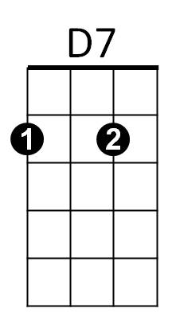
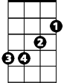
Em
G C Am
Is the home team still on fire, do they still win all their games,
D D7 G
And by the way, did she mention my name?

G C Am
Is the landlord still a loser, do his signs hang in the hall,
D D7 G
Are the young girls still as pretty in the city in the fall?
C Am
BARITONE
Does the laughter on their faces still put the sun to shame,
C
G
D D7 G
And by the way, did she mention my name.
C D G Em
Did she mention my name just in passing, and when the talk ran high,
A7 D D7

Did the look in her eye seem far away,
D
Am
D7
G C Am
Is the old roof still leaking, when the late snow turns to rain,
D D7 G
And by the way, did she mention my name?

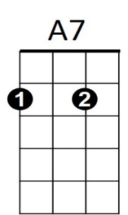
C D G Em
Did she mention my name just in passing, and looking at the rain,
Em
A7 D D7
Do you remember if she dropped a name or two?
G C Am
Won't you say hello from someone, there'll be no need to explain,
D D7 G
And by the way, did she men - tion my name?
Let Me Be There (John Rostil)
C
F
Intro: Chords folr ending
C F C
Wherever you go, wherever you may wander in your life,
G7
Surely you know, I’ll always want to be there
G7
C7
C C7 F
Just holding your hand, and standing by to catch you
C G7 C F C
When you fall, seeing you through, in everything you do

Chorus:
C
Let me be there in your morning
F
Let me be there in your night
C G7
Let me change whatever’s wrong, and make it right
C C7
Let me take you to that wonderland
F
That only two can share
C G7 C F C
All I ask yo-u. is let me be there

C F C
Watching you grow, and going through the changes in your life
BARITONE
G7
C
F
That’s how I’ll know, I’ll always want to be there
C C7 F
Whenever you feel you need a friend to lean on,
C G7 C F C
Here I am, whenever you call, you know I’ll be there
C7
G7
G7
C7

(Chorus)

C G7 C F C
Ending: All I ask yo-u. is let me be there
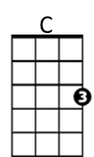
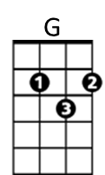
Let Your Love Flow

Intro: Chords for last 3 lines of chorus

C
There's a reason for the sunshiny sky

There's a reason why I'm, feeling so high
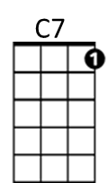
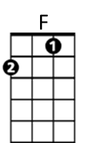
G C
Must be the season when those love lights shine all around us

So let that feeling grab you deep inside

And send you reeling where your love can't hide
G C C7
And then go stealing through the moonlit night with your lover

Chorus:
F
Just let your love flow like a mountain stream
C
And let your love grow with the smallest of dreams
G C C7
And let your love show and you'll know what I mean- it's the season
F
Let your love fly like a bird on the wing
C
And let your love bind you to all living things
G C
And let your love shine and you'll know what I mean- that's the reason
BARITONE
C
C7
F
C
G
There's a reason for the warm sweet nights

And there's a reason for the candle lights
G C
Must be the season when those love lights shine all around us

So let that wonder take you into space

And lay you under its loving embrace
G C C7
Just feel the thunder as it warms your face- you can't hold back

(CHORUS TWICE AND FADE)

Love Will Keep Us Alive (Eagles)
Written by Pete Vale, Jim Capaldi & Paul Carrack
Key C
Intro.: C Am F G
Am
C
G

C Am
I was standin' all alone against the world outside
F G
You were searchin' for a place to hide
C Am
Dm
F
Lost and lonely, now you've given me the will to survive
F G C
When we're hungry, love will keep us a-live

C Am
Don't you worry sometimes you've just gotta let it ride
F G
The world is changin' right before your eyes
C Am
Now I've found you, there's no more empti-ness inside
F G C
When we're hungry, love will keep us a-live

Chorus:
F Am
BARITONE

I would die for you, climb the highest mountain
Dm
F
G
C
Am
Dm G
Baby, there's nothin' I wouldn't do

C Am
Now I've found you, there's no more empti-ness inside
F G C
When we're hungry, love will keep us a-live

(Chorus)

Repeat first verse

(Ending)
F G C
When we're hungry, love will keep us a-live
F G C
When we're hungry, love will keep us a-live
Save The Last Dance For Me (Doc Pomus and Mort Shuman)

Intro: Chords for Chorus

C G
You can dance, every dance with the guy who gives you the eye, let him hold you tight
C
You can smile ~ every smile for the man who held your hand 'neath the pale moonlight,

But

Chorus:

F C
Don't forget who's taking you home and in whose arms you're gonna be ~~
G C
So darling, save the last dance for me
G
C
F
BARITONE

C G
Oh I know ~ that the music's fine like sparkling wine, Go and have your fun
C
Laugh and sing ~ but while we're apart, Don't give your heart to anyone, and

(CHORUS)

C G C
Baby don't you know I love you so - Can't you feel it when we touch
G C
I will never never let you go - Cause I love you oh so much

C G
You can dance ~ go and carry on, till the night is gone and it's time to go
C
If he asks ~ if you're all alone can he take you home, you must tell him no, and

(CHORUS)

ending:
G C (2x)
So darling, save the last dance for me

Sloop John B (Traditional)
C
F
Am
G
G7
C7
C F C F C
We come on the sloop John B, my grandfather and me
Am G
Around Nassau town we did roam
C C7 F
Drinking all night, got into a fight
C G C
I feel so broke up, I want to go home

Chorus:
C F C F C
So hoist up the John B's sail, see how the mainsail sets
Am G G7
Call for the Captain ashore, let me go home
C C7 F
Let me go home, I wanna go home,
C G C
I feel so broke up, I wanna go home

C F C F C
The first mate he got drunk and broke in the cap'n's trunk
Am G
The constable had to come and take him a-way
C
F
G
Am
G7
C7
C C7 F
BARITONE
Sheriff, John Stone, why don't you leave me a-lone
C G C
Well, I feel so broke up, I wanna go home

(Chorus)

C F C F C
The poor cook he caught the fits, threw away all my grits
Am G
Then he took and he ate up all of my corn
C C7 F
Let me go home, why don't they let me go home,
C G C
This is the worst trip I've ever been on

(Chorus)

C G C
This is the worst trip I've ever been on
C G C
This is the worst trip I've ever been on

