The U.S. Air Force (The Air Force Song) (Capt. Robert Crawford) Key C

C G C
Off we go into the wild blue yonder,
F C G
Climbing high into the sun
C G C
Here they come zooming to meet our thunder,
D G
At 'em boys, Give 'er the gun!
C G C
Down we dive, spouting our flame from under,
F E7
Off wi th one hell of a roar!
Am A Dm D7
We live in fame or go down in flame,
C G C G
Nothing can stop the U.S. Air Force!

C G C
Minds of men fashioned a crate of thunder,
F C G
Sent it high into the blue
C G C
Hands of men blasted the world asunder;
D G
How they lived God only knew! (God only knew!)
C G C
Souls of men dreaming of skies to conquer,
F E7
Gave us wings, ever to soar!
Am A Dm D7
With scouts before and bombers galore,
C G C G
Nothing will stop the U.S. Air Force!

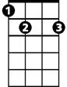
E7


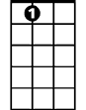







D
E7
F
C
G
D7
Dm
A
Am
BARITONE

C G C
Here's a toast to the host of those who
F C G
Love the vastness of the sky,
C G C
To a friend we send a message of his
D G
Brother men who fly.
C G C
We drink to those who gave their all of old, then,
F E7
Down we roar to score the rainbow's pot of gold.
Am A Dm D7
A toast to the host of men we boast,
C D C G
the U.S. Air Force!

C G C
Off we go into the wild sky yonder,
F C G
Keep the wings level and true;
C G C
If you'd live to be a grey-haired wonder
D G
Keep the nose out of the blue!
C G C
Flying men, guarding the nation's border,
F E7
We'll be there, followed by more!
Am A Dm D7
In ech-e-lon we carry on.
C G C
Nothing will stop the U.S. Air Force!


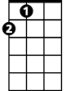
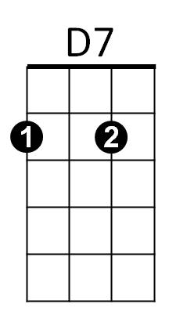
Am
A
Dm
G
F
D
C

The U.S. Air Force (The Air Force Song) (Capt. Robert Crawford) Key G

G D G
Off we go into the wild blue yonder,
C G D
Climbing high into the sun
G D G
Here they come zooming to meet our thunder,
A D
At 'em boys, Give 'er the gun!
G D G
Down we dive, spouting our flame from under,
C B7
Off with one hell of a roar!
Em E Am A7
We live in fame or go down in flame,
G D G D
Nothing can stop the U.S. Air Force!

G D G
Minds of men fashioned a crate of thunder,
C G D
Sent it high into the blue
G D G
Hands of me n blasted the world asunder;
A D
How they lived God only knew! (God only knew!)
G D G
Souls of men dreaming of skies to conquer,
C B7
Gave us wings, ever to soar!
Em E Am A7
With scouts before and bombers galore,
G D G D
Nothing will stop the U.S. Air Force!
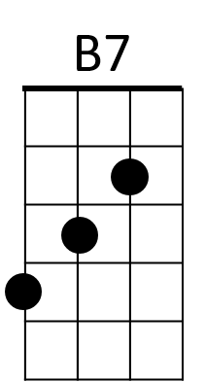
A
C
D
G

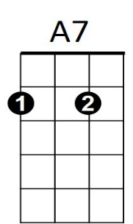
BARITONE
B7
Am
A
C
D
G
E
Em

G D G
Here's a toast to the host of those who
C G D
Love the vastness of the sky,
G D G
To a friend we send a message of his
A D
Brother men who fly.
G D G
We drink to those who gave their all of old, then,
C B7
Down we roar to score the rainbow's pot of gold.
Em E Am A7
A toast to the host of men we boast,
G D G D
the U.S. Air Force!

G D G
Off we go into the wild sky yonder,
C G D
Keep the wings level and true;
G D G
If you'd live to be a grey-haired wonder
A D
Keep the nose out of the blue!
G D G
Flying men, guarding the nation's border,
C B7
We'll be there, followed by more!
Em E Am A7
In ech-e-lon we carry on.
G D G
Nothing will stop the U.S. Air Force!
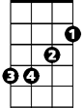
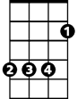
Em
A7
Am
E

