
8th Annual
Alabama Uke Fest
Lake Guntersville, Ala.
September 25, 2021

Play It With The Pros
All songs in the key of the original performers.

If you have a capo, you can play the Uke Fest song sheet for
“River” and “Mr. Tambourine Man.”

Ticket To Ride (A) (Separate pages for C- and G- Tuning)
River (E)
Winchester Cathedral (C)
Raindrops Keep Fallin’ On My Head (F)
A Summer Song (A) (Available in the keys of A and G)
Mr. Tambourine Man (D)

Print Edition as of August 22, 2021
Ticket to Ride (John Lennon & Paul McCartney, 1965) (A)
Ticket To Ride by The Beatles (A) – C Tuning Chords
4/4 Time – Tempo 125 bpm

Introduction (4 measures): | A Asus2 | (4x)  A Asus2 A Asus2 A - Asus2 | A Asus2  1. I think I'm gonna be sad, I think it's to-day, yeah  A Asus2 A Asus2 Bm | E  The girl that's driving me mad is going a-way  Chorus 1  F#m G6 – D7  She's got a ticket to ride  F#m G6 – Gmaj7  She's got a ticket to ride  F#m E  She's got a ticket to ride  A Asus2 | A Asus2 |  But she don't care  A Asus2 A Asus2 A - Asus2 | A Asus2 |  2. She said that living with me is bringing her down yeah  A Asus2 A Asus2 Bm | E  For she would never be free when I was a-round. Chorus  Chorus 2  F#m G6 – D7 – G6  She's got a ticket to ride  F#m G6 – Gmaj7  She's got a ticket to ride  F#m E  She's got a ticket to ride  A A7 | A A7sus2 |  But she don't care  Bridge  D D7 D D7  I don't know why she's ridin' so high  D7 E E7  She ought to think right, she ought to do right by me  D D7 D D7  Be-fore she gets to saying good-bye  D D7 E | E5  She ought to think right, she ought to do right by me | 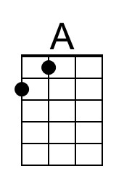 | 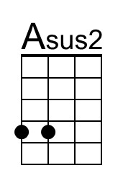
 | 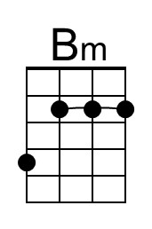 | 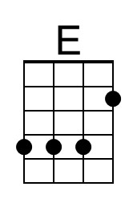
 | 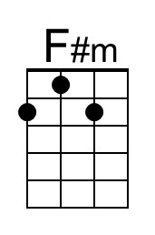 | 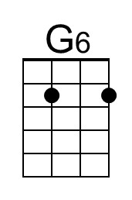
 | 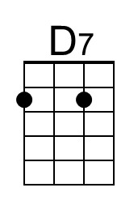 | 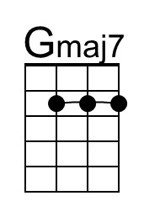
 | 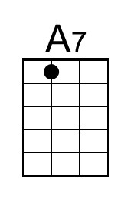 | 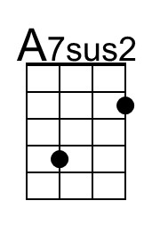
 | 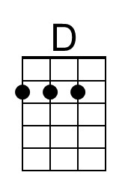 | 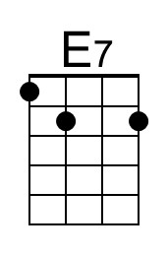

Ticket To Ride (A) – Page 2

A Asus2 A Asus2 A - Asus2 | A Asus2
3. I think I'm gonna be sad, I think it's to-day, yeah
A Asus2 A Asus2 Bm | E
The girl that's driving me mad is going a-way

Chorus 1
F#m G6 – D7 F#m G6 – Gmaj7
She's got a ticket to ride. She's got a ticket to ride.
F#m E
She's got a ticket to ride
A Asus2 | A Asus2 |
But she don't care

Bridge
D D7 D D7
I don't know why she's ridin' so high
D7 E E7
She ought to think right, she ought to do right by me
D D7 D D7
Be-fore she gets to saying good-bye
D D7 E | E5
She ought to think right, she ought to do right by me

A Asus2 A Asus2 A - Asus2 | A Asus2 |
4. She said that living with me is bringing her down yeah
A Asus2 A Asus2 Bm | E
For she would never be free when I was a-round. Chorus

Chorus 2
F#m G6 – D7 – G6 F#m G6 – Gmaj7
She's got a ticket to ride. She's got a ticket to ride
F#m E A Asus2 |
She's got a ticket to ride. But she don't care.

Outro.
NC A Asus2 A Asus2 A Asus2
My baby don't care. _ My baby don't care.
A Asus2 A Asus2 A Asus2 A Asus2 A
_ My baby don't care. _ My baby don't care.
Ticket to Ride (John Lennon & Paul McCartney, 1965) (A)
Ticket To Ride by The Beatles (A) – G Tuning Chords
4/4 Time – Tempo 125 bpm

Introduction (4 measures): | A Asus2 | (4x)  A Asus2 A Asus2 A - Asus2 | A Asus2  1. I think I'm gonna be sad, I think it's to-day, yeah  A Asus2 A Asus2 Bm | E  The girl that's driving me mad is going a-way.  Chorus 1  F#m G6 – D7  She's got a ticket to ride,  F#m G6 – Gmaj7  She's got a ticket to ride,  F#m E  She's got a ticket to ride,  A Asus2 | A Asus2 |  But she don't care.  A Asus2 A Asus2 A - Asus2 | A Asus2 |  2. She said that living with me is bringing her down, yeah.  A Asus2 A Asus2 Bm | E  For she would never be free when I was a-round.  Chorus  F#m G6 – D7  She's got a ticket to ride,  F#m G6 – Gmaj7  She's got a ticket to ride,  F#m E  She's got a ticket to ride,  A A7 | A A7sus2  But she don't care.  Bridge  D D7 D D7  I don't know why she's ridin' so high,  |¯¯¯¯ 3 ¯¯¯¯| D |¯¯¯¯ 3 ¯¯¯¯| D7 E E7  She ought to think right, she ought to do right by me.  D D7 D D7  Be-fore she gets to saying good-bye,  |¯¯¯¯ 3 ¯¯¯¯| D |¯¯¯¯ 3 ¯¯¯¯| D7 E E7  She ought to think right, she ought to do right by me. | 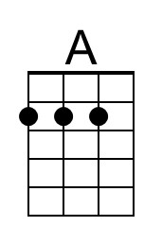 | 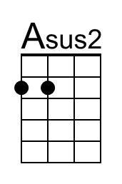
 | 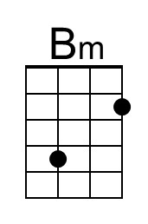 | 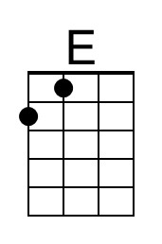
 | 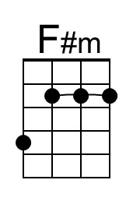 | 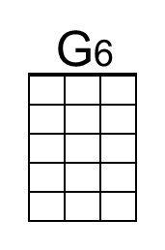
 | 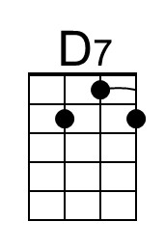 | 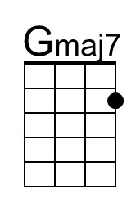
 | 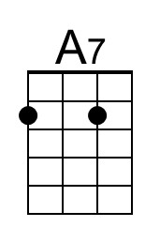 | 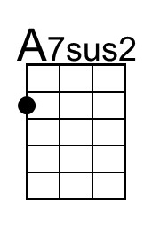
 | 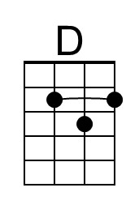 | 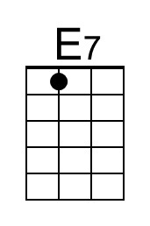

Ticket To Ride (A) – Page 2

A Asus2 A Asus2 A - Asus2 | A Asus2
3. I think I'm gonna be sad, I think it's to-day, yeah
A Asus2 A Asus2 Bm | E
The girl that's driving me mad is going a-way, yeah!

Chorus
F#m G6 – D7 F#m G6 – Gmaj7
She's got a ticket to ride, She's got a ticket to ride,
F#m E
She's got a ticket to ride,
A Asus2 | A Asus2
But she don't care.

Bridge
D D7 D D7
I don't know why she's ridin' so high,
|¯¯¯¯ 3 ¯¯¯¯| D |¯¯¯¯ 3 ¯¯¯¯| D7 E E7
She ought to think right, she ought to do right by me.
D D7 D D7
Be-fore she gets to saying good-bye,
|¯¯¯¯ 3 ¯¯¯¯| D |¯¯¯¯ 3 ¯¯¯¯| D7 E E5
She ought to think right, she ought to do right by me.

A Asus2 A Asus2 A - Asus2 | A Asus2
4. She said that living with me is bringing her down yeah
A Asus2 A Asus2 Bm | E |
For she would never be free when I was a-round. Ah.

Chorus
F#m G6 – D7 F#m G6 – Gmaj7
She's got a ticket to ride. She's got a ticket to ride
F#m E A Asus2 |
She's got a ticket to ride. But she don't care.

Outro.
NC A Asus2 A Asus2 A Asus2
My baby don't care. _ My baby don't care.
A Asus2 A Asus2 A Asus2 A Asus2 | A (Hold)
_ My baby don't care. _ My baby don't care.

River (Bill Staines, circa 1979) (E)
River by Bill Staines from "The Whistle of the Jay" (E)
¾ Time – Tempo 150 bpm

Intro E | A | E | A

E A E B7
I was born in the path of the winter wind. I was raised where the mountains are old.
E A E B7 E | E
Their springtime waters came dancing down, and I remember the tales they told.

E A E B7
The whistling ways of my younger days, Too quickly have faded on by.
E A E B7 E | E |
But all of their memories linger on, like the light in a fading sky.

Chorus
E A B7 E A B7
River, take me a-long in your sun-shine, sing me your song.
A E
Ever moving and winding and free.
A E A E
You rolling old river, you changing old river,
A B7 A E | E | E | E
Let's you and me, river, run down to the sea.

E A E
I've been to the city and back again.
B7
I've been moved by some things that I've learned.
E A E
Met a lot of good people an’ I called them friends,
B7 E | E
Felt the change when the seasons turned.

 |  | 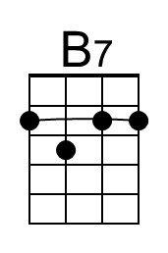 |  | Bari |  |  | 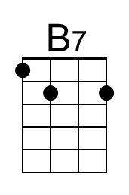
River (E) – Page 2

E A E B7
I've heard all the songs that the children sing, And listened to love's melo-dies.
E A E B7 E | E |
I've felt my own music within me rise, like the wind in the autumn trees.

Chorus
E A B7 E A B7
River, take me a-long in your sun-shine, sing me your song.
A E
Ever moving and winding and free.
A E A E
You rolling old river, you changing old river,
A B7 A E | E | E | E
Let's you and me, river, run down to the sea.

E A E
Some-day when the flowers are blooming still,
B7
Someday when the grass is still green,
E A E B7 E | E
My rolling waters will round the bend, flow into the open sea.

E A E
So, here's to the rainbow that's followed me here.
B7
And here's to the friends that I know.
E A E B7 | E
And here's to the song that's within me now, I will sing it wher-e’er I go. Chorus

Outro
E A B7 E A B7
River, take me a-long in your sun-shine, sing me your song.
A E A E A E
Ever moving and winding and free. You rolling old river, you changing old river
A B7 | B7
Let's you and me, river,
B7 A B7 A E | E | A | B7 | D
Run down to the sea. [Hold]

Winchester Cathedral (Geoff Stephens, 1966) (C)
Winchester Cathedral by The New Vaudeville Band (C)
4/4 Time – Tempo 128 bpm

Intro (Instrumental for first 2 lines)
C Am G G6
Oh-bo-de-o-do, oh-bo-de-o-do,
G7 G6 C G7
Oh-bo-de-o-do de-do-duh.

C Am G G6
Oh-bo-de-o-do, oh-bo-de-o-do,
G7 G6 C ↓ G7 ↓
Oh-bo-de-o-do de-do-duh.

C G
__ Winchester Cathedral, __ you're bringing me down.
G7 C
__ You stood and you watched as, __ my baby left town.
C G
__ You could have done something, __ but you didn't try.
G7 C
__ You didn't do nothing; __ you let her walk by.

Bridge
C C7 F
__ Now everyone knows just how much I needed that gal,
D D7
__ She wouldn't have gone far a-way.
G D7 G7
If only you'd started ringing your bell.

 | 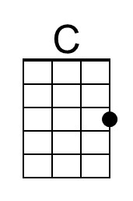 | 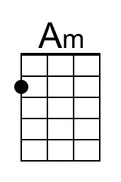 | 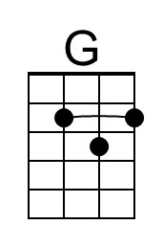 |  | 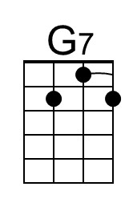
 | 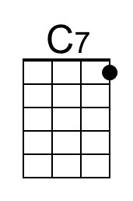 | 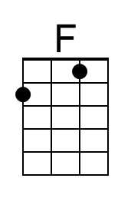 |  |  | 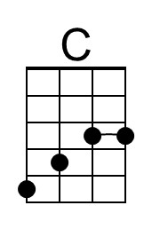

Winchester Cathedral (C) – Page 2

C G
__ Winchester Cathedral, __ you're bringing me down.
G7 C
__ You stood and you watched as, __ my baby left town.

(Instrumental / Kazoo)
C G
__ Winchester Cathedral, __ you're bringing me down.
G7 C
__ You stood and you watched as, __ my baby left town.

Bridge
C C7 F
__ Now everyone knows just how much I needed that gal,
D D7
__ She wouldn't have gone far a-way.
G D7 G7
If only you'd started ringing your bell.

C G
__ Winchester Cathedral, __ you're bringing me down.
G7 C
__ You stood and you watched as, __ my baby left town.

Outro
C Am G G6
Oh-bo-de-o-do, oh-bo-de-o-do,
G7 G6 C ↓ C ↓ [Hold]
Oh-bo-de-o-do de-do-duh. [High C]

 |  | Bari | 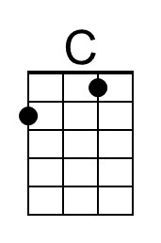 | 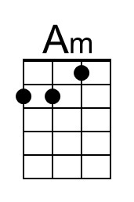 | 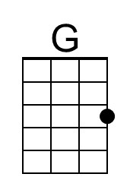 |  | 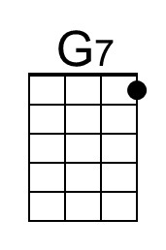
 |  |  | 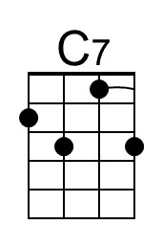 | 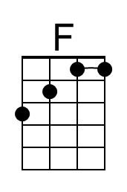 |  |  | 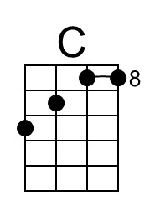

Raindrops Keep Falling On My Head (Burt Bacharach & Hal David, 1969) (F)
Raindrops Keep Falling On My Head by B. J. Thomas (F)
4/4 Time – Tempo 104 bpm

Intro (4 Measures) | F C | Bb C | (2x) (Pattern: ↓_↓↑↓↑ ↓_↓↑↓↑ ↓_↓↑↓↑ ↓___)

F Fmaj7
Raindrops keep falling on my head
F7 Bb Am7
And just like the guy whose feet are too big for his bed
D7 Am7 D7 Gm7 C7
Nothing seems to fit _ those _ raindrops are falling on my head
F Fmaj7
They keep falling _ so I just did me some talking to the sun
F7 Bb Am7
And I said I didn't like the way he got things done
D7 Am7 D7 Gm7 C7
Sleeping on the job _ those _ raindrops are falling on my head,
They keep falling _ ( Pause – Palm Mute or Hold )

Reprise
Tacet F Fmaj7
But there's one thing _ I know,
Bb C7 Am7
The blues they send to meet me won't de-feat me
D7 Gm7 | Bb Bb C | (2x) ( ↓↑↓ ↑_)
It won't be long till happiness steps up to greet me.

 |  |  | 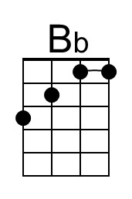 | 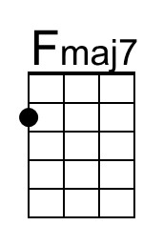 | 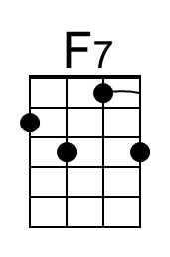
 | 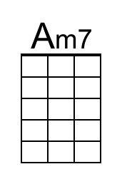 |  | 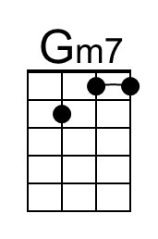

Raindrops Keep Falling On My Head (F) – Page 2

F Fmaj7
Raindrops keep falling on my head.
F7 Bb Am7
But that doesn't mean my eyes will soon be turning red
D7 Am7 D7 Gm7 C7
Crying's not for me _ cause _ I'm never gonna stop the rain by complaining
F Bb C7 F
Because I'm free __ nothing’s worrying me. (Join Reprise at “thing;”)

Reprise (First 2 lines Instrumental; sing last line)
Tacet F Fmaj7
………….. thing _ I know,
Bb C7 Am7
The blues they send to meet me won't de-feat me
[Sing] D7 Gm7 | Bb Bb C | (2x)
It won't be long till happiness steps up to greet me. ( ↓↑↓ ↑_)

F Fmaj7
Raindrops keep falling on my head.
F7 Bb Am7
But that doesn't mean my eyes will soon be turning red
D7 Am7 D7 Gm7 C7
Crying's not for me _ cause _ I'm never gonna stop the rain by complaining
F | [ Ritard ] Bb C7 F [Hold]
Because I'm free . . . __ nothing’s . . . worrying . . . me.

 |  | Bari |  |  | 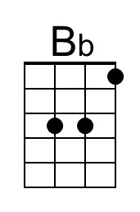 | 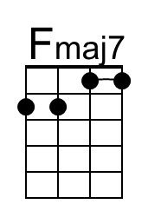 | 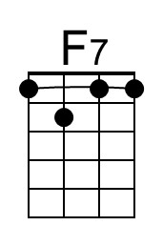
 |  |  | 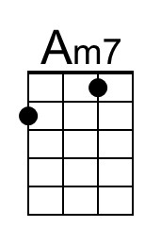 |  | 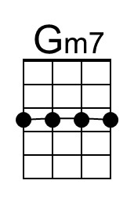 |  | 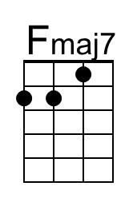

A Summer Song (Chad Stuart, Clive Metcalfe & Keith Noble, 1964) (A)
A Summer Song by Chad and Jeremy (A)
4/4 Time – Tempo 124 bpm

Intro | A C#m | D E | (2x)  A C#m D E A C#m D  Trees swaying in the summer breeze  E A C#m D E A  Showing off their silver leaves as we walked by  C#m D E A C#m D  Soft kisses on a summer’s day  E A C#m D E A C#m D E  Laughing all our cares a-way, Just you and I.  A C#m D E A C#m D  Sweet sleepy warmth of summer nights  E A C#m D E A C D A  Gazing at the distant lights In the starry sky  Bridge  D E A F#m  __They say that all good things must end, some-day,  D E F#m ( ↓ _ ↓ ↓ _ ↓ _ ↓ ↓)  Autumn leaves must fall  A C#7  But don’t you know, that it hurts me so,  F#m C#m Bm  To say goodbye to you - ooo,  F#m E F#m E  __ Wish you didn’t have to go. __ No, no, no, no…  A C#m D  And when the rain  E A C#m D  Beats against my window pane  E A C#m D  I’ll think of summer days a-gain  E A C# | D E | A C | D A |  And dream of you. |  | 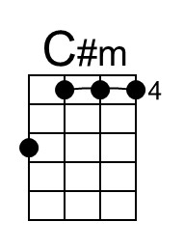
 | 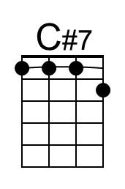
 | 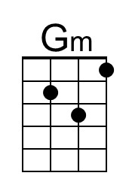 | 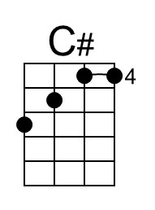
 |  | 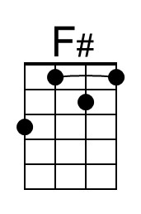

A Summer Song (A) – Page 2

Bridge  D E A F#m  _They say that all good things must end, some-day,  D E F#m ( ↓ _ ↓ ↓ _ ↓ _ ↓ ↓)  Autumn leaves must fall  A C#7  But don’t you know, that it hurts me so,  F#m C#m Gm  To say goodbye to you - ooo,  F#m E F#m E  __ Wish you didn’t have to go. __ No, no, no, no…  A C#m D E A C#m D  And when the rain Beats against my window pane,  E A C#m D  I’ll think of summer days a-gain,  E A C#m D  And dream of you.  E A C# | D E | F#  And dream of you. (Hold) |  | 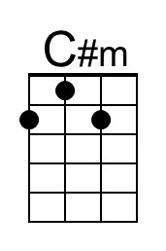
 | 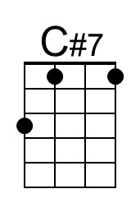 | 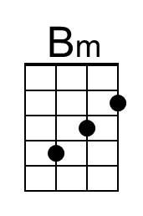
 | 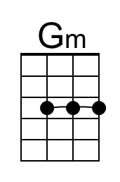 | 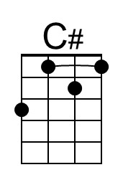
 |  | 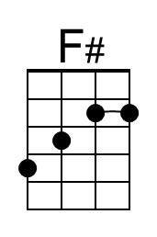

This song is also available in the key of G (the following two pages);
a capo would be needed to play with the performers.
A Summer Song (Chad Stuart, Clive Metcalfe & Keith Noble, 1964) (G)
A Summer Song by Chad and Jeremy (A)
4/4 Time – Tempo 124 bpm

Intro | G Bm | C D | (2x)

G Bm C D G Bm C
Trees swaying in the summer breeze
D G Bm C D G
Showing off their silver leaves as we walked by
Bm C D G Bm C
Soft kisses on a summer’s day
D G Bm C D G Bm C D
Laughing all our cares a-way, Just you and I.

G Bm C D G Bm C
Sweet sleepy warmth of summer nights
D G Bm C
Gazing at the distant lights
D G A# C G
In the starry sky

Bridge
C D G Em
__They say that all good things must end, some-day,
C D Em
Autumn leaves must fall ( ↓ _ ↓ ↓ _ ↓ _ ↓ ↓)
G B7
But don’t you know, that it hurts me so,
Em Bm Am
To say goodbye to you-ooo,
Em D Em D
__ Wish you didn’t have to go. __ No, no, no, no…

G Bm C D G Bm C
And when the rain Beats against my window pane,
D G Bm C
I’ll think of summer days a-gain
D G B | C D | G A# | C G |
And dream of you.
 | 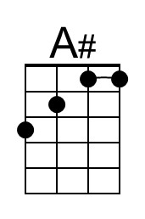 | 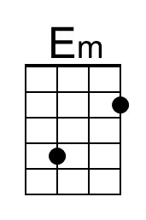
 | 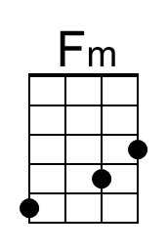 | 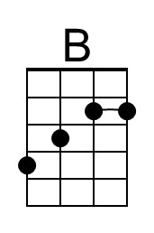

A Summer Song (G) – Page 2

Bridge
C D G Em
__They say that all good things must end, some-day,
C D Em
Autumn leaves must fall ( ↓ _ ↓ ↓ _ ↓ _ ↓ ↓)
G B7
But don’t you know, that it hurts me so,
Em Bm Fm
To say goodbye to you-ooo,
Em D Em D
__ Wish you didn’t have to go. __ No, no, no, no…

G Bm C D G Bm C
And when the rain Beats against my window pane
D G Bm C D G Bm C
I’ll think of summer days a-gain And dream of you.
D G B | C D | E
And dream of you. (Hold)

 | 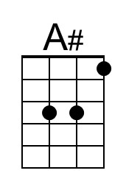 | 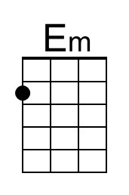
 | 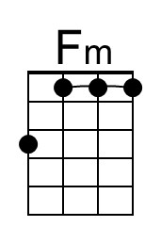 | 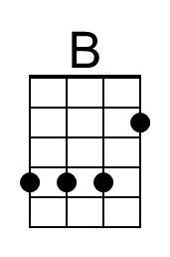
 |  | 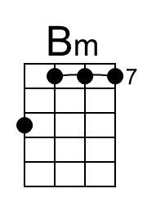

Mr Tambourine Man (Bob Dylan, 1964) (D)
Mr. Tambourine Man by The Byrds (1965) (D)
4/4 Time – Tempo = 120 bpm

[ Hum Tune, if helpful ] Strum pattern: D G A A
Intro | D G A A | (4x) DDU - DUDU – DUDU _UDU

Chorus
G A D G
Hey! Mr. Tambourine Man, play a song for me,
D G A Asus2 | A Asus2 |
I'm not sleepy and there ain't no place I'm goin' to.
G A D G
Hey! Mr. Tambourine Man, play a song for me,
D G A D Dsus4 | D Dsus4 |
In the jingle jangle morning, I'll come followin' you.

G A D G
Take me for a trip upon your magic swirlin' ship,
D G
All my senses have been stripped,
D G
And my hands can't feel to grip,
D G
And my toes too numb to step,
D G A Asus2 | A Asus2
Wa - it only for my boot heels to be wanderin'.

 |  |  |  | Bari
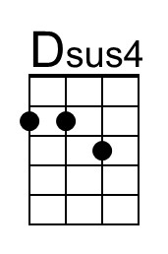 |  |  |  |  | 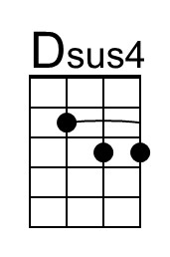

Mr. Tambourine Man (D) – Page 2

G A
I'm ready to go anywhere,
D G
I'm ready for to fade,
D G
On to my own parade,
D G
Cast your dancin' spell my way,
A Asus2 | A Asus2 |
I promise to go under it.

Chorus
G A D G
Hey! Mr. Tambourine Man, play a song for me,
D G A Asus2 | A Asus2 |
I'm not sleepy and there ain't no place I'm goin' to.
G A D G
Hey! Mr. Tambourine Man, play a song for me,
D G A D . . . |
In the jingle jangle morning, I'll come followin' you.

[ Hum Tune, if helpful ] Strum pattern: D G A A
Outro | D G A A | (4x) DDU - DUDU – DUDU _UDU

