
8th Annual
Alabama Uke Fest
Lake Guntersville, Ala.
September 25, 2021

Ticket To Ride
River
Winchester Cathedral
Raindrops Keep Fallin’ On My Head
A Summer Song
Mr. Tambourine Man

Change Log – August 22ND
Added key of original performers.

Print Edition as of August 22, 2021
Ticket to Ride (John Lennon & Paul McCartney, 1965) (C)
Ticket To Ride by The Beatles (A)
4/4 Time – Tempo 125 bpm

Intro | C Csus4 | (4x)

C C - Csus4 C
I think I'm gonna be sad, I think it's to-day, yeah
C7 Dm | G
The girl that's driving me mad is going away.

Chorus
Am F Am Bbmaj7
She's got a ticket to ride she's got a ticket to ri-i-de
Am Gm C | C
She's got a ticket to ride, and she don't care.

C C - Csus4 | C
She says that living with me is bringing her down, yeah
C7 Dm | G
But she will never be free when I was a-round. Chorus

Bridge
F
I don't know why she's riding so high
G
She ought to think right, she ought to do right by me
F
Be-fore she gets to saying good-bye
G | G
She ought to think right, she ought to do right by me

C C - Csus4 C
I think I'm gonna be sad, I think it's to-day, yeah
C7 Dm | G
The girl that's driving me mad is going a-way. Chorus

 | 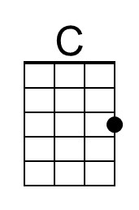 | 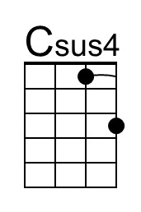 | 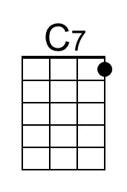 | 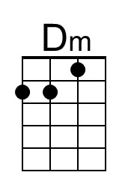 | 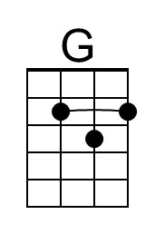
 | 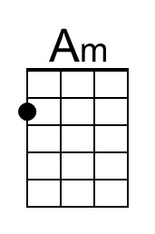 | 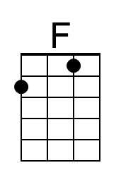 | 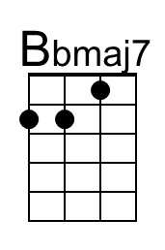 | 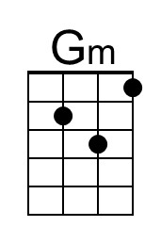
Ticket To Ride (C) – Page 2

Bridge
F
I don't know why she's riding so high
G
She ought to think right, she ought to do right by me
F
Be-fore she gets to saying good-bye
G | G
She ought to think right, she ought to do right by me

C C - Csus4 | C
She says that living with me is bringing her down, yeah
C7 Dm | G
But she will never be free when I was a-round.

Chorus
Am F Am Bbmaj7
She's got a ticket to ride she's got a ticket to ri-i-de
Am Gm C | C
She's got a ticket to ride, and she don't care

Outro
Tacet C Csus4
My baby don’t care.
C Csus4 C Csus4 (3x) End on C
__ My baby don’t care.

C-Tuning Intro (2x)  | C G E C D G | C G E C D G |  A |-------------|-------------|  E |---3-0-----3-|---3-0-----3-|  C |-0-----0-2---|-0-----0-2---|  G |-------------|-------------| | G-Tuning Intro (2x)  | C G E C D G | C G E C D G |  E |---3-0-----3-|---3-0-----3-|  B |-1-----1-3---|-1-----1-3---|  G |-------------|-------------|  D |-------------|-------------|

 |  | Bari | 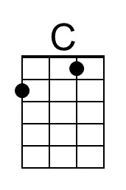 | 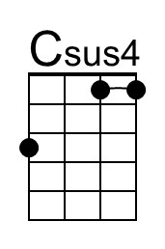 | 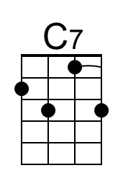 | 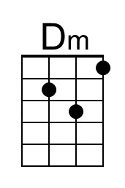 | 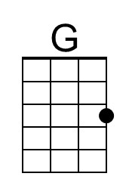
 |  |  | 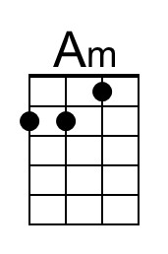 | 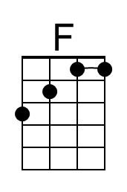 | 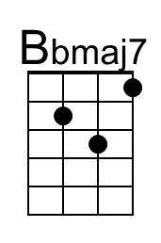 | 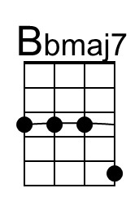 | 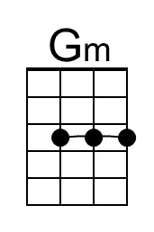

River (Bill Staines, circa 1979) (D)
River by Bill Staines from "The Whistle of the Jay" (E)
¾ Time – Tempo 150 bpm

Intro D | G | D | G

D G D
I was born in the path of the winter wind.
A7
I was raised where the mountains are old.
D G D A7 D | D
Their springtime waters came dancing down, and I remember the tales they told.

D G D
The whistling ways of my younger days
A7
Too quickly have faded on by.
D G D A7 D | D
But all of their memories linger on, like the light in a fading sky.

Chorus
D G A7 D G A7
River, take me a-long in your sun-shine, sing me your song.
G D
Ever moving and winding and free.
G D G D
You rolling old river, you changing old river,
G A7 G D | D | D | D
Let's you and me, river, run down to the sea.

D G D
I've been to the city and back again.
A7
I've been moved by some things that I've learned.
D G D
Met a lot of good people an’ I called them friends,
A7 D | D
Felt the change when the seasons turned.

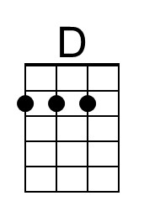 |  | 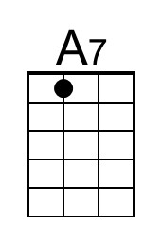 |  | Bari | 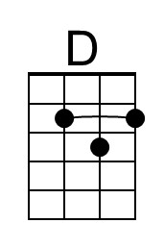 |  | 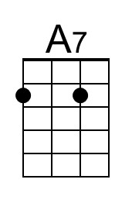
River (D) – Page 2
D G D
I've heard all the songs that the children sing
A7
And listened to love's melo-dies.
D G D A7 D | D
I've felt my own music within me rise, like the wind in the autumn trees.

Chorus
D G A7 D G A7
River, take me a-long in your sun-shine, sing me your song.
G D
Ever moving and winding and free.
G D G D
You rolling old river, you changing old river,
G A7 G D | D | D | D
Let's you and me, river, run down to the sea.

D G D
Some-day when the flowers are blooming still,
A7
Someday when the grass is still green,
D G D A7 D | D
My rolling waters will round the bend, flow into the open sea.

D G D
So, here's to the rainbow that's followed me here.
A7
And here's to the friends that I know.
D G D A7 D | D
And here's to the song that's within me now, I will sing it wher-e’er I go. Chorus

Outro
D G A7 D G A7
River, take me a-long in your sun-shine, sing me your song.
G D G D G D
Ever moving and winding and free. You rolling old river, you changing old river
G A7 | A7
Let's you and me, river,
G A7 G D | D | G | A7 | D [Hold]
Run down to the sea.

Winchester Cathedral (Geoff Stephens, 1966) (C)
Winchester Cathedral by The New Vaudeville Band (C)
4/4 Time – Tempo 128 bpm

Intro (Instrumental for first 2 lines)
C Am G G6
Oh-bo-de-o-do, oh-bo-de-o-do,
G7 G6 C G7
Oh-bo-de-o-do de-do-duh.

C Am G G6
Oh-bo-de-o-do, oh-bo-de-o-do,
G7 G6 C ↓ G7 ↓
Oh-bo-de-o-do de-do-duh.

C G
__ Winchester Cathedral, __ you're bringing me down.
G7 C
__ You stood and you watched as, __ my baby left town.
C G
__ You could have done something, __ but you didn't try.
G7 C
__ You didn't do nothing; __ you let her walk by.

Bridge
C C7 F
__ Now everyone knows just how much I needed that gal,
D D7
__ She wouldn't have gone far a-way.
G D7 G7
If only you'd started ringing your bell.

 |  |  |  | 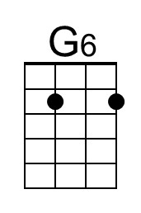 | 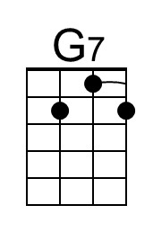
 |  |  |  | 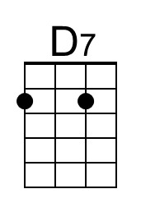 | 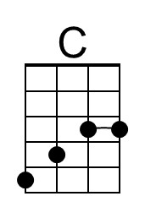

Winchester Cathedral (C) – Page 2

C G
__ Winchester Cathedral, __ you're bringing me down.
G7 C
__ You stood and you watched as, __ my baby left town.

(Instrumental / Kazoo)
C G
__ Winchester Cathedral, __ you're bringing me down.
G7 C
__ You stood and you watched as, __ my baby left town.

Bridge
C C7 F
__ Now everyone knows just how much I needed that gal,
D D7
__ She wouldn't have gone far a-way.
G D7 G7
If only you'd started ringing your bell.

C G
__ Winchester Cathedral, __ you're bringing me down.
G7 C
__ You stood and you watched as, __ my baby left town.

Outro
C Am G G6
Oh-bo-de-o-do, oh-bo-de-o-do,
G7 G6 C ↓ C ↓ [Hold]
Oh-bo-de-o-do de-do-duh. [High C]

 |  | Bari |  |  |  | 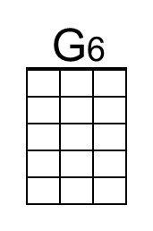 | 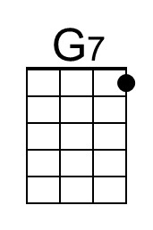
 |  |  |  |  |  | 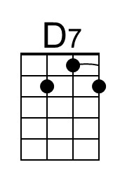 | 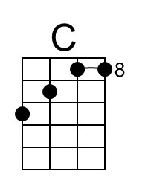

Raindrops Keep Falling On My Head (Burt Bacharach & Hal David, 1969) (C)
Raindrops Keep Falling On My Head by B. J. Thomas (F)
4/4 Time – Tempo 104 bpm

Intro (4 Measures) | C G | F G | (2x) (Pattern: ↓_↓↑↓↑ ↓_↓↑↓↑ ↓_↓↑↓↑ ↓___)

C Cmaj7
Raindrops keep falling on my head
C7 F Em7
And just like the guy whose feet are too big for his bed
A7 Em7 A7 Dm7 G7
Nothing seems to fit _ those _ raindrops are falling on my head
Tacet C Cmaj7
They keep falling _ so I just did me some talking to the sun
C7 F Em7
And I said I didn't like the way he got things done
A7 Em7 A7 Dm7 G7
Sleeping on the job _ those _ raindrops are falling on my head
They keep falling _ ( Pause – Palm Mute or Hold )

Reprise
Tacet C Cmaj7
But there's one thing _ I know,
F G7 Em7
The blues they send to meet me won't de-feat me
A7 Dm7 | F F G _ | (2x) ( ↓↑↓ ↑_)
It won't be long till happiness steps up to greet me.

 |  |  |  | 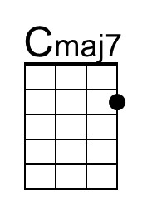
 | 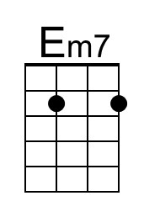 |  | 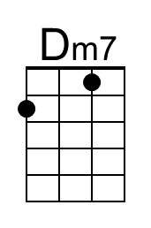

Raindrops Keep Falling On My Head (C) – Page 2

C Cmaj7
Raindrops keep falling on my head.
C7 F Em7
But that doesn't mean my eyes will soon be turning red
A7 Em7 A7 Dm7 G7
Crying's not for me _ cause _ I'm never gonna stop the rain by complaining
C F G7 C
Because I'm free __ nothing’s worrying me. (Join Reprise at “thing;”)

Reprise (First 2 lines Instrumental; sing last line)
Tacet C Cmaj7
………….. thing _ I know,
F G7 Em7
The blues they send to meet me won't de-feat me
[Sing] A7 Dm7 | F F G _ | (2x) ( ↓↑↓ ↑_)
It won't be long till happiness steps up to greet me

C Cmaj7
Raindrops keep falling on my head.
C7 F Em7
But that doesn't mean my eyes will soon be turning red
A7 Em7 A7 Dm7 G7
Crying's not for me _ cause _ I'm never gonna stop the rain by complaining
C | [ Ritard ] F G7 C [Hold]
Because I'm free . . . __ nothing’s . . . worrying . . . me.

 |  | Bari |  |  |  | 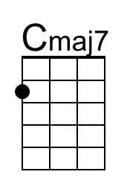
 |  |  | 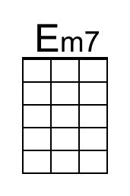 |  | 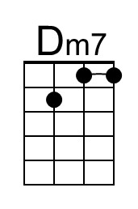

A Summer Song (Chad Stuart, Clive Metcalfe & Keith Noble, 1964) (F)
A Summer Song by Chad and Jeremy (A)
4/4 Time – Tempo 124 bpm
Intro F Am B♭ C (2x)

F Am B♭ C F Am B♭
Trees swaying in the summer breeze
C F Am B♭ C F
Showing off their silver leaves as we walked by
Am B♭ C F Am B♭
Soft kisses on a summer’s day
C F Am
Laughing all our cares a-way
B♭ C F Am B♭ C
Just you and I

F Am B♭ C F Am B♭
Sweet sleepy warmth of summer nights
C F Am B♭
Gazing at the distant lights
C F A♭ B♭ F
In the starry sky
Bridge
B♭ C F Dm
__They say that all good things must end, some-day,
B♭ C Dm ↓ _ ↓ ↓ _ ↓ _ ↓ ↓
Autumn leaves must fall
F A7
But don’t you know, that it hurts me so,
Dm Am Gm
To say goodbye to you-ooo,
Dm C Dm C
__ Wish you didn’t have to go. __ No, no, no, no…

F Am B♭
And when the rain
C F Am B♭
Beats against my window pane
C F Am B♭
I’ll think of summer days a-gain
C F A | B♭ C | F A♭ | B♭ F |
And dream of you.
 | 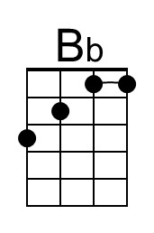
 | 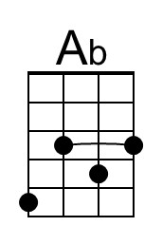 | 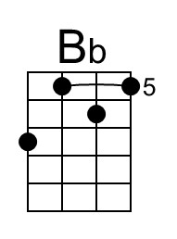

A Summer Song (F) – Page 2

Bridge
B♭ C F Dm
__They say that all good things must end, some-day,
B♭ C Dm ↓ _ ↓ ↓ _ ↓ _ ↓ ↓
Autumn leaves must fall
F A7
But don’t you know, that it hurts me so,
Dm Am Gm
To say goodbye to you-ooo,
Dm C Dm C
__ Wish you didn’t have to go. __ No, no, no, no…

F Am B♭
And when the rain
C F Am B♭
Beats against my window pane
C F Am B♭
I’ll think of summer days a-gain
C F Am B♭
And dream of you.
C F A | B♭ C | D (Hold)
And dream of you.

 | 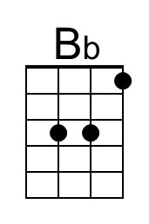
 | 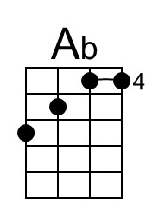 | 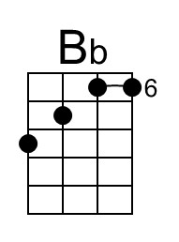

Mr. Tambourine Man (Bob Dylan, 1964) (C)
Mr. Tambourine Man by The Byrds (1965) (D)
4/4 Time – Tempo 120 bpm

[ Hum Tune, if helpful ] C F G G
Intro | C F G G | (4x) (Pattern: DUD_ DUDU DUDU _UDU)

Chorus
F G C F
Hey! Mr. Tambourine Man, play a song for me,
C F G Gsus2 | G Gsus2
I'm not sleepy and there ain't no place I'm goin' to.
F G C F
Hey! Mr. Tambourine Man, play a song for me,
C F G C Csus4 | C Csus4
In the jingle jangle morning, I'll come followin' you.

F G C F
Take me for a trip upon your magic swirlin' ship,
C F C F
All my senses have been stripped, and my hands can't feel to grip.
C F
And my toes too numb to step,
C F G Gsus2 | G Gsus2
Wait only for my boot heels, to be wanderin'.

 |  |  |  | Bari
 |  | 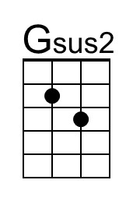 |  |  |  |  | 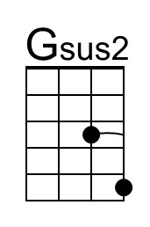

Mr. Tambourine Man (C) – Page 2

F G C F
I'm ready to go anywhere, I'm ready for to fade,
C F C F
On to my own parade. Cast your dancin' spell my way,
G Gsus2 | G Gsus2
I promise to go under it.

Chorus
F G C F
Hey! Mr. Tambourine Man, play a song for me,
C F G Gsus2 | G Gsus2
I'm not sleepy and there ain't no place I'm goin' to.
F G C F
Hey! Mr. Tambourine Man, play a song for me,
C F G C
In the jingle jangle morning, I'll come followin' you.

Outro | C F G G | (4x) | C (Hold)

C F G G
(Pattern: DUD_ DUDU DUDU _UDU)

C-Tuning Intro (2x)
C G C A G F E | D C F D D C C D (2x)
A ----------0----------|------------------------|-
E ----3--------3--1--0-|-------1----------------|-
C -0-----0-------------|-2--0-----2--2--0--0--2-|-
G ---------------------|------------------------|-

G-Tuning Intro (2x)
C G C A G F E | D C F D D C C D (2x)
E ----3-----5--3--1--0-|-------1----------------|-
B -2-----2-------------|-3--1-----3--3--1--1--3-|-
G ---------------------|------------------------|-
D ---------------------|------------------------|-

