Ukulele Lady (Richard A. Whiting / Gus Kahn) Key C

C G7 C
I saw the splendor of the moonlight
Ab7 G7 C
On Honolu lu Bay
G7 C
There something tender in the moonlight
Ab7 G7 C
On Honolu lu Bay

Am
And all the beaches are full of peaches
Em
Who bring their 'ukes' along
C
And in the glimmer of the moonlight
D7 G7
They love to sing this song

Chorus:

C Em Am G7

If you like-a Ukulele Lady
C
C Em Am C
Ukulele Lady like-a you
Dm G7 Dm G7
If you like to linger where it's shady
Dm G7 C
Ukulele Lady linger too
Em Am G7
If you kiss a Ukulele Lady
C Em Am C
While you promise ever to be true
Dm G7 Dm G7
And she see another Ukulele
Dm G7 C
BARITONE
Lady fool around with you
F C
Maybe she'll sigh, maybe she'll cry
D7 G G7
Maybe she'll find somebody else bye and bye

C Em Am G7

To sing to When it's cool and shady
Em
C Em Am C
Where the tricky Wiki Wackies woo
Dm G7 Dm G7
If you like a Ukulele Lady
Dm C
Ukulele Lady like a you

C G7 C
She used to sing to me by moonlight
Ab7 G7 C
On Honolu lu Bay
G7 C
Fond mem'rys cling to me by moonlight
Ab7 G7 C
Although I'm far a way

Am
Someday I'm going where eyes are glowing
Em
And lips are made to kiss
C
To see somebody in the moonlight
D7 G7
And hear the song I miss

(CHORUS)

Dm C
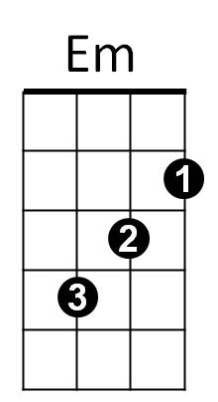
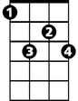

Ukulele Lady like a you –oo -oo
Am
Ab7
G7

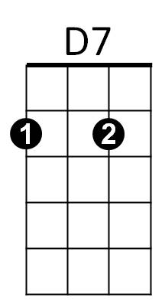


G
F

Dm

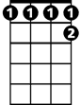

Ab7
G7
C
Am



D7
Dm
G
F

Ukulele Lady (Richard A. Whiting / Gus Kahn) Key F
F C7 F
I saw the splendor of the moonlight
Db7 C7 F
On Honolu lu Bay
C7 F
There something tender in the moonlight
Db7 C7 F
On Honolu lu Bay

Dm
And all the beaches are full of peaches
Am
Who bring their 'ukes' along
F
And in the glimmer of the moonlight
G7 C7
They love to sing this song

Chorus:

F Am Dm C7
If you like-a Ukulele Lady
F Am Dm F
Ukulele Lady like-a you
Gm C7 Gm C7
If you like to linger where it's shady
Gm C7 F
Ukulele Lady linger too
F Am Dm C7
If you kiss a Ukulele Lady
F Am Dm F
While you promise ever to be true
Gm C7 Gm C7
And she see another Ukulele
Gm C7 F
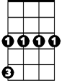
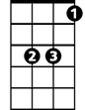
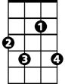
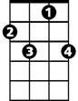
Lady fool around with you
Gm
Am
G7
Bb
F
Db7
BARITONE
C7
C

Bb F
Maybe she'll sigh, maybe she'll cry
G7 C C7
Maybe she'll find somebody else bye and bye

F Am Dm C7
To sing to when it's cool and shady
F Am Dm F
Where the tricky Wiki Wackies woo
Gm C7 Gm C7
If you like a Ukulele Lady
Gm F
Ukulele Lady like a you
F C7 F
She used to sing to me by moonlight
Db7 C7 F
On Honolu lu Bay
C7 F
Fond mem'rys cling to me by moonlight
Db7 C7 F
Although I'm far a way

Dm
Someday I'm going where eyes are glowing
Am
And lips are made to kiss
F
To see somebody in the moonlight
G7 C7
And hear the song I miss

(CHORUS)

Gm F
Ukulele Lady like a you –oo -oo
C7
F
Db7
Dm
Am
Dm
Gm
C
G7
Bb

