Un Poco Loco (Adrian Molina / Germaine Franco) Key C

Intro: F C Bb F C F

Ahhhhhh-ahhoo ayy!
C F
What color's the sky?
C F
Ay, mi amor, ay, mi amor
C F
You tell me that it's red,
C F
Ay, mi amor, ay, mi amor
C F
Where should I put my shoes?
C F
Ay , mi amor, ay, mi amor
C F
You say, "put them on your head!"
C F
Ay, mi amor, ay, mi amor

Chorus:
Bb
You make me un poco loco,
C F
Un poquititito loco
Bb
The way you keep me guessing,
C F
I'm nodding and I’m yessing
C
I'll count it as a blessing
Bb C F D7
That I'm only - un poco loco


BARITONE
D7


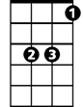
F
C
Bb

G C
The loco that you make me
D G
It is just un poco crazy
C
The sense that you're not making
D G
The liberties you're taking
D
Leaves my cabeza shaking
C D G
You're just - un poco loco

(4X) G C
He's just un poco crazy
D G
Leaves my cabeza shaking

Ending:

G C D G



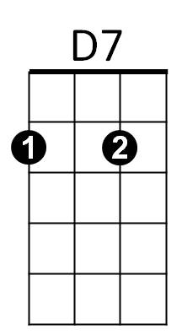
Un poquitititi titi titi titi tititito loco
F
Bb
C
D
G

G
D

Un Poco Loco (Adrian Molina / Germaine Franco) Key G

Intro: C G F C G C

Ahhhhhh-ahhoo ayy!
G C
What color's the sky?
G C
Ay, mi amor, ay, mi amor
G C
You tell me that it's red,
G C
Ay, mi amor, ay, mi amor
G C
Where should I put my shoes?
G C
Ay, mi amor, ay, mi amor
G C
You say, "put them on your head!"
G C
Ay, mi amor, ay, mi amor

Chorus:
F
You make me un poco loco,
G C
Un poquititito loco
F
The way you keep me guessing,
G C
I'm nodding and I’m yessing
G
I'll count it as a blessing
F G C A7
That I'm only - un poco loco

D G
The loco that you make me
A D
It is just un poco crazy
G
The sense that you're not making
A D
The liberties you're taking
A
Leaves my cabeza shaking
G A D
You're just - un poco loco

(4X) D G
He's just un poco crazy
A D
Leaves my cabeza shaking

Ending:

D G A D
Un poquitititi titi titi titi tititito loco
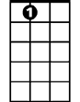
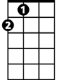
D
F
G
A7
C
A

D

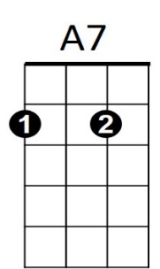
BARITONE
G
F
A
C

