Venus in Blue Jeans (Howard Greenfield / Jack Keller) Key C

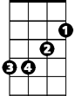

C Em Dm G / C Em Dm G
C
Em
Dm

C Em
She's Venus in blue jeans,
Dm G C
Mona Lisa with a ponytail
Dm G Em Am



She's a walking talking work of art,
G
D
Am
D G
She's the girl who stole my heart

C Em


My Venus in blue jeans,
C7
F
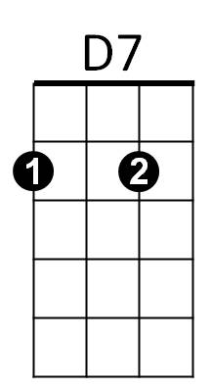
Dm G C
Is th e Cinderella I a - dore
Dm G Em Am
She's my very special angel too,
Dm G C C7
A fairy tale come true

F Em
They say there's sev en wonders in the world,
Dm G C C7
BARITONE


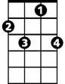

But what they say is out of date
F
C
Em
Dm
G
Am
D
C7
D7
F Em
There's more seven wonders in the world,
D D7 G
I just met number eight

(2X) EXTEND LAST LINE AT END)
C Em
My Venus in blue jeans,
Dm G Em
Is everything I hoped she'd be
Dm G Em A
A teenage goddess from above,
Dm G G7 C
And she belongs to me

C Em Dm G / C Em Dm G

Venus in Blue Jeans (Howard Greenfield / Jack Keller) Key F
F Am Gm C / F Am Gm C
Gm
F
Am

F Am
She's Venus in blue jeans,
Gm C F
Mona Lisa with a ponytail
Gm C Am Dm
C
Dm
G
She's a walking talking work of art,
G C
She's the girl who stole my heart

F Am
My Venus in blue jeans,
Bb
F7
G7
Gm C F
Is the Cinderella I a - dore
Gm C Am Dm
She's my very special angel too,
Gm C F F7
A fairy tale come true

Bb Am
They say there's seven wonders in the world,
Gm C F F7
BARITONE
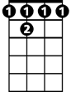
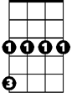
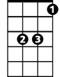
But what they say is out of date
G7
F 7
G
Dm
Am
F
Gm
C
Bb
Bb Am
There's more seven wonders in the world,
G G7 C
I just met number eight

(2X) EXTEND LAST LINE AT END)
F Am
My Venus in blue jeans,
Gm C Am
Is everything I hoped she'd be
Gm C Am D
A teenage goddess from above,
Gm C C7 F
And she belongs to me

F Am Gm C / F Am Gm C

Venus in Blue Jeans (Howard Greenfield / Jack Keller) Key G
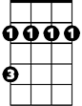
G Bm Am D / G Bm Am D
Bm
G
Am

G Bm
She's Venus in blue jeans,
Am D G
Mona Lisa with a ponytail
Am D Bm Em
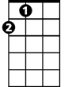
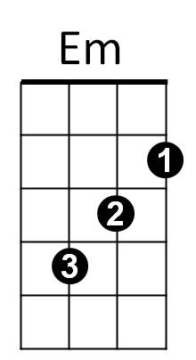
She's a walking talking work of art,
A
D
A D
She's the girl who stole my heart

G Bm
My Venus in blue jeans,
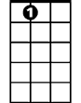
Am D G
C
A7
G7
Is the Cinderella I a - dore
Am D Bm Em
She's my very special angel too,
Am D G G7
A fairy tale come true

C Bm
They say there's seven wonders in the world,
BARITONE
Am D G G7
Bm
Am
G
But what they say is out of date
C Bm
There's more seven wonders in the world,
A A7 D
I just met number eight
A
Em
D
(2X) EXTEND LAST LINE AT END)
G Bm
My Venus in blue jeans,
Am D Bm
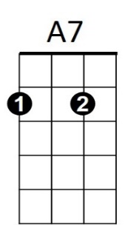
Is everything I hoped she'd be
G7
C
Am D Bm E
A teenage goddess from above,
Am D D7 G
And she belongs to me

G Bm Am D / G Bm Am D

