Waikiki (Andy Cummings)


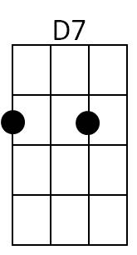
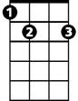

F E7
C7
Gm
E7
F
There's a feeling deep in my heart
F D7
Stabbing at me just like a dart
Gm C7 F C7
It's a feeling heavenly


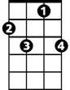
F E7
Bb
F7


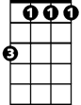
I see memories out of the past
G7
Dm
Bb m
F D7
Me mories that always will last
G7 C7
Of a place beside the sea


F F7
Am
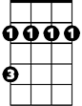
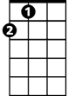
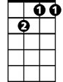
Ahhhhhhhh Waikîkî
Bm
A
Gm7
Bb Bbm
At night when the shadows are falling
F Dm G7
I hear the rolling surf calling
Gm7 C7 F
Calling and calling to me

F F7
Waikîkî
Bb Bbm
BARITONE
Tis for you that my heart is yearning
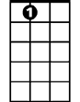
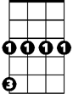
F Dm G7
E7
Gm
F
D7
My thoughts are always returning
Gm7 C7 F E7
Out there to you across the sea

A Bm E7
Your tropic nights and your wonderful charms
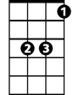
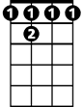
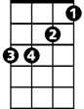
A Bm E7
C7
Bb
F 7
Dm
Bb m
Are ever in my memory
A Bm E7
And I recall when I held in my arms
Am Gm7 C7
An angel sweet and heavenly

F F7

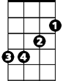
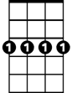
Waikîkî
Am
A
Bm
Gm7
G7
Bb Bbm
My whole life is empty without you
F Dm G7
I miss that magic about you
Gm7 C7 F D7
Magic beside the sea
Gm C7 Gm C F
Magic of Waikî - Magic of Waikiki

