Wake Me Up When September Ends Key C
(Michael Pritchard / Frank E. / Iii Wright / Billie Joe Armstrong)

C Cmaj7
Summer has come and passed
Am G
The innocent can never last
F Fm C
Wake me up when September ends
C Cmaj7
Like my father's come to pass
Am G
Seven years has gone so fast
F Fm C
Wake me up when September ends

Chorus:

Am Em
Here comes the rain again
F C
Falling from the stars
Am Em

Drenched in my pain again
C
F G
Becoming who we are
C Cmaj7
As my memory rests
Am G

But never forgets what I lost
F
F Fm C
Wake me up when September ends

BARITONE

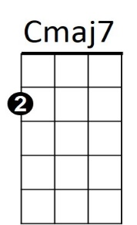
Am
G
C

C Cmaj7
Summer has come and passed
Am G
The innocent can never last
F Fm C
Wake me up when September ends
C Cmaj7
Ring out the bells again
Am G
Like we did when spring began
F Fm C
Wake me up when September ends

(Chorus)

(First Verse)

F Fm C (3X)
Wake me up when September ends



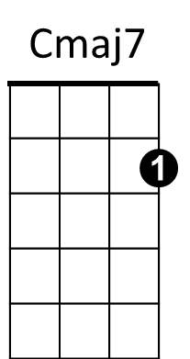
G
Am

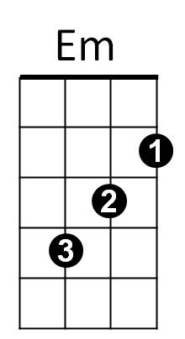
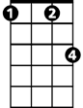
Fm

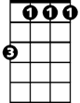

Em
Fm
F

Wake Me Up When September Ends Key G
(Michael Pritchard / Frank E. / Iii Wright / Billie Joe Armstrong)

G Gmaj7
Summer has come and passed
Em D
The innocent can never last
C Cm G
Wake me up when September ends
G Gmaj7
Like my father's come to pass
Em D
Seven years has gone so fast
C Cm G
Wake me up when September ends

Chorus:

Em Bm
Here comes the rain again
C G
Falling from the stars
Em Bm
Drenched in my pain again
C D
Becoming who we are
G Gmaj7
As my memory rests
Em D
C
But never forgets what I lost
C Cm G
Wake me up when September ends

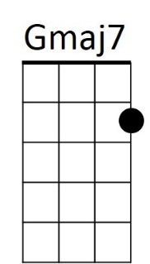
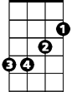
Bm
Cm
C
Em
G
D

G Gmaj7
Summer has come and passed
Em D
The innocent can never last
C Cm G
Wake me up when September ends
G Gmaj7
Ring out the bells again
Em D
Like we did when spring began
C Cm G
Wake me up when September ends

(Chorus)

(First Verse)

C Cm G (3X)
Wake me up when September ends

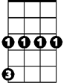
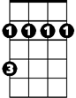

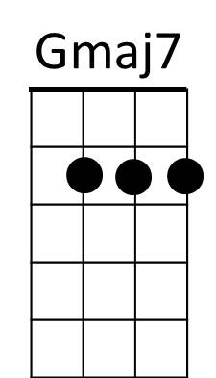
Cm
G
Bm
D
BARITONE

