Way Down Yonder In New Orleans (C)
(John Turner Layton, Jr. & Henry Creamer, 1922)

Starting Note: G

Intro: | C | Am | C | Abº7 | C | G7 | C |  G7 C  Way down yonder in New Orleans, In the land of the dreamy scenes.  G7 G7 C  There's a Garden of E - den, __ you know what I mean.  G7 C  Creole babies with flashin' eyes, __ Softly whisper with tender sighs.  C7 F (F7 E7 Eb7)  Stop! Oh, won't you give your lady fair, a little smile.  D7 G7  Stop! You bet your life you'll linger there, a little while.  | 1st Ending:  C Am  There is Heaven right here on Earth,  C Abº7  With those beautiful queens.  C G7 C  Way down yonder in New Or..leans.  Repeat From Top  | 2nd Ending:  C Am C Abº7  They’ve got angels right here on earth, Wearing little blue jeans.  C G7 C  Way down yonder in New Or..leans. (2x) |  |  |  |  |  |  | 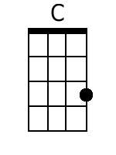 | 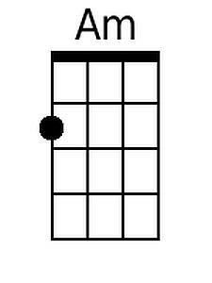
 |  |  |  |  |  |  | 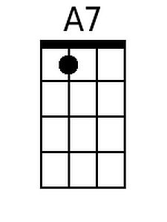 | 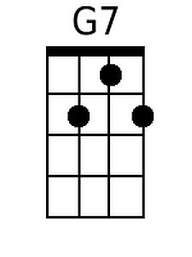
 |  |  |  |  |  |  | 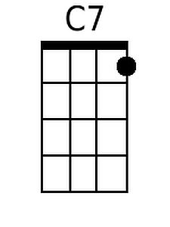 | 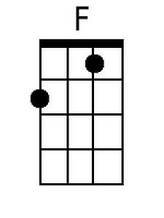
 |  |  |  |  |  |  | 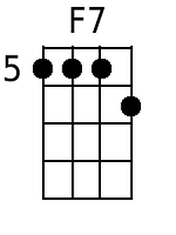 | 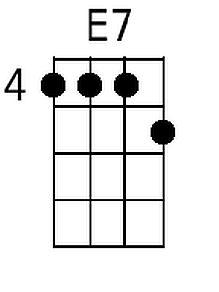
 |  |  |  |  |  |  | 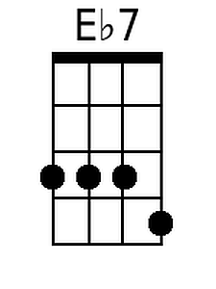 | 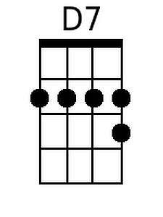
 |  |  |  |  |  |  |  | 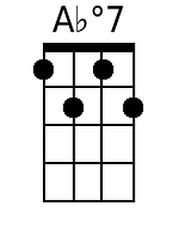
Baritone
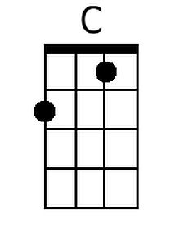 | 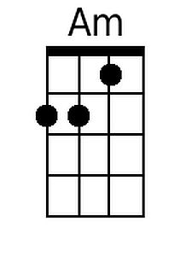 | 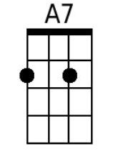 | 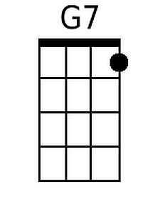 | 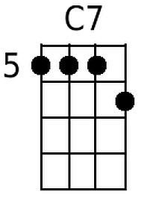 | 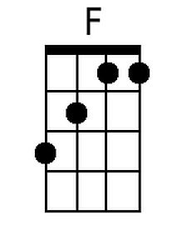
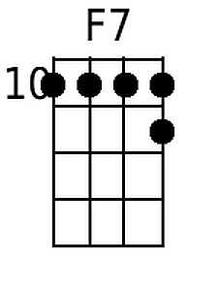 | 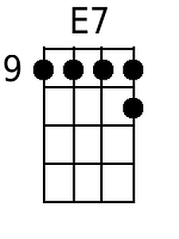 | 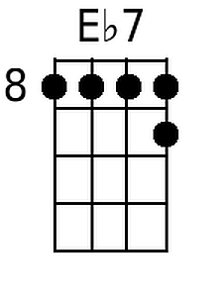 | 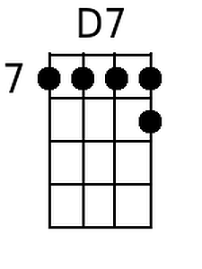 | 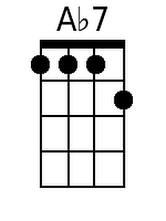 |  | Alternate F#7 Forms for Bari | 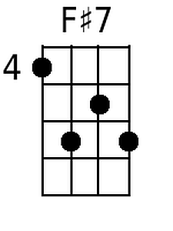 | 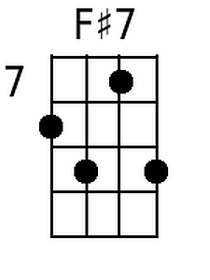

Way Down Yonder In New Orleans (G)
(John Turner Layton, Jr. & Henry Creamer, 1922)

Starting Note: D

Intro: | G | Em | G | Ebº7 | G | D7 | G |  D7 G  Way down yonder in New Orleans, in the land of the dreamy scenes.  D7 D7 G  There's a Garden of E - den, __ you know what I mean.  D7 G  Creole babies with flashin' eyes, _ Softly whisper with tender sighs.  G7 C (C7 B7 Bb7)  Stop! Oh, won't you give your lady fair, a little smile.  A7 D7  Stop! You bet your life you'll linger there, a little while.  | 1st Ending:  G Em  There is Heaven right here on Earth,  G Ebº7  With those beautiful queens.  G D7 G  Yeah, way down yonder in New Or..leans.  Repeat From Top  | 2nd Ending:  G Em G Ebº7  They've got angels right here on earth, wearing little blue jeans.  G D7 G  Yeah, way down yonder in New Or..leans. (2x) |  |  |  |  |  |  | 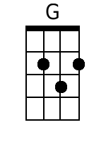 | 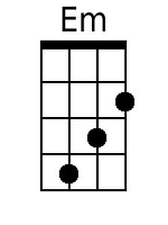
 |  |  |  |  |  |  | 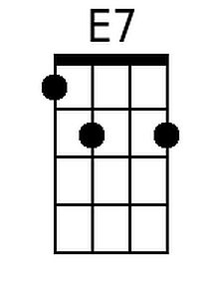 | 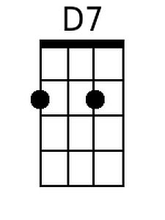
 |  |  |  |  |  |  |  | C
 |  |  |  |  |  |  | 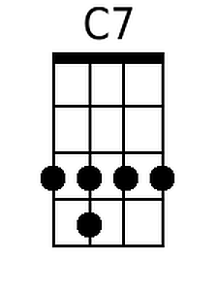 | 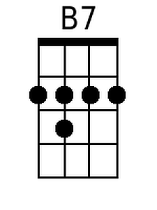
 |  |  |  |  |  |  | 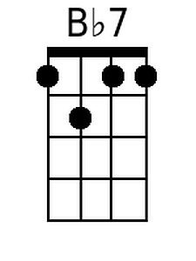
 |  |  |  |  |  |  |  | 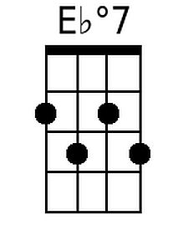
Baritone
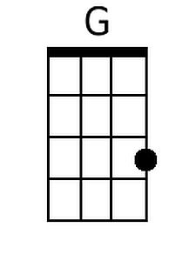 | 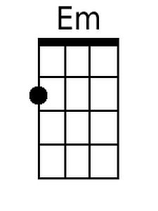 | 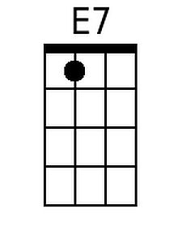 | 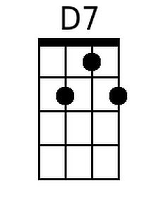
 | 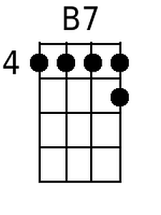 | 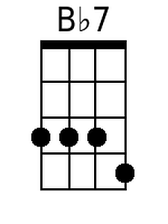 | 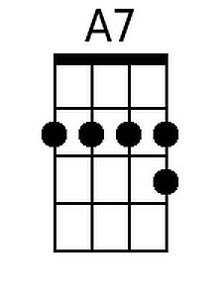 | 