
We Need a Little Christmas (J. Herman, 1966)
C51 C
We Need A Little Christmas by Angela Lansbury From "Mame" (1966) (Eb @ 130 BPM)
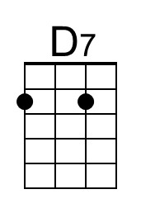
Intro (last 1 & ½ lines of first verse) Dm | G | C | Am | D | D7 | G | G7  C G C G C Am A7  Haul out the holly, put up the tree be-fore my ~ spirit falls again  Dm G Dm G Dm G Dm G A - A7  Fill up the stocking, I may be rushing things, but ~ deck the halls again now. For we  Chorus  Dm G C Am F G  Need a little Christmas, right this very minute. Candles in the window,  C C7 Dm G C Am  Carols at the Spinet, Yes, we need a little Christmas, right this very minute  D D7 G G7  It hasn't snowed a single flurry but Santa, dear, we're in a hurry.  C G C G C Am A7  So climb down the chimney, put up the brightest string of ~ lights I've ever seen  Dm G Dm G Dm G Dm G A - A7  Slice up the fruitcake, it's time we hung some tinsel ~ on that evergreen bough.  Dm G C Am F G  For I've grown a little leaner, grown a little colder, grown a little sadder  C Am Dm G C Am  Grown a little older. And I need a little angel, sitting on my shoulder.  Dm F G C  I need a little Christmas now.  C G C G C Am A7  Haul out the holly. Well, once I taught you all to ~ live each living day.  Dm G Dm G Dm G  Fill up the stocking. But Auntie Mame, it's one week ~  Dm G A - A7  Past Thanks-giving Day now. But we . . .Chorus  C G C G C Am A7  So climb down the chimney. It's been a long time since I ~ felt good, neighborly  Dm G Dm G Dm G Dm G A - A7  Slice up the fruitcake, it's time we hung some tinsel ~ on that evergreen bough,  Dm G C Am F G  For we need a little music, need a little laughter, need a little singing,  C C7 Dm G C Am  Ringing through the rafter. And we need a little snappy, happy ever after  Dm F G C Dm F G C  We need a little Christmas now. We need a little Christ - mas now! |  |  |  |  |  |  |  |  | 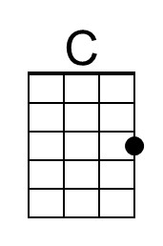
 |  |  |  |  |  |  |  |  | 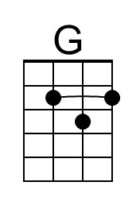
 |  |  |  |  |  |  |  |  | 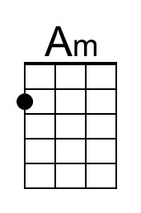
 |  |  |  |  |  |  |  |  | 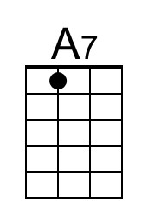
 |  |  |  |  |  |  |  |  | 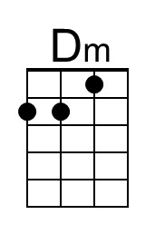
 |  |  |  |  |  |  |  |  | 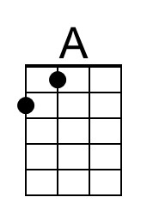
 |  |  |  |  |  |  |  |  | 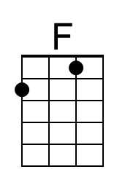
 |  |  |  |  |  |  |  |  | 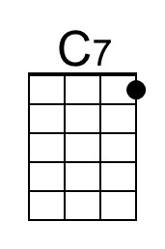
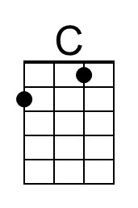 | 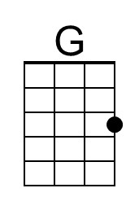 | 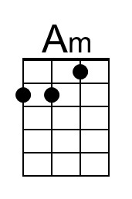 | 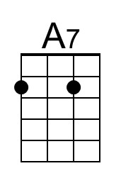 | 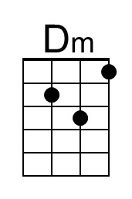 | 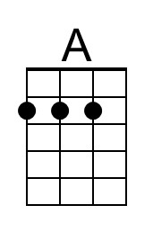 | 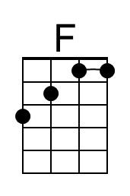 | 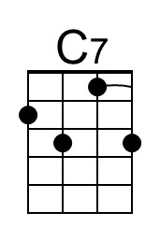 | 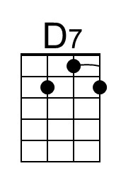

We Need a Little Christmas (J. Herman, 1966)
C51 G
We Need A Little Christmas by Angela Lansbury From "Mame" (1966) (Eb @ 130 BPM)

Intro (last 1 & ½ lines of first verse) Am | D | G | Em | A | A7 | D | D7

G D G D G Em E7
Haul out the holly, put up the tree be-fore my ~ spirit falls again
Am D Am D Am D Am D E - E7
Fill up the stocking, I may be rushing things, but ~ deck the halls again now. For we

Chorus
Am D G Em C D
We need a little Christmas, right this very minute. Candles in the window,
G G7 Am D G Em
Carols at the Spinet, Yes, we need a little Christmas, right this very minute
A A7 D D7
It hasn't snowed a single flurry but Santa, dear, we're in a hurry

G D G D G Em E7
So climb down the chimney, put up the brightest string of ~ lights I've ever seen
Am D Am D Am D Am D E - E7
Slice up the fruitcake, it's time we hung some tinsel ~ on that evergreen bough.
Am D G Em C D
For I've grown a little leaner, grown a little colder, grown a little sadder
G Em Am D G Em
Grown a little older. And I need a little angel, sitting on my shoulder.
Am C D G
I need a little Christmas now.

G D G D G Em E7
Haul out the holly. Well, once I taught you all to ~ live each living day.
Am D Am D Am D
Fill up the stocking. But Auntie Mame, it's one week ~
Am D E - E7
Past Thanks-giving Day now. But we . . .Chorus

G D G D G Em E7
So climb down the chimney. It's been a long time since I ~ felt good, neighborly
Am D Am D Am D Am D E - E7
Slice up the fruitcake, it's time we hung some tinsel ~ on that evergreen bough,
Am D G Em C D
For we need a little music, need a little laughter, need a little singing,
G G7 Am D G Em
Ringing through the rafter. And we need a little snappy, happy ever after
Am C D G Am C D G
We need a little Christmas now. We need a little Christ - mas now!

 |  |  |  |  |  |  |  |  | 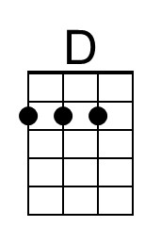
 |  |  |  |  |  |  |  |  | 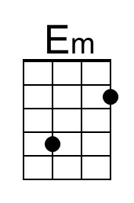
 |  |  |  |  |  |  |  |  | 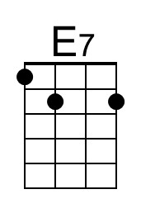
 |  |  |  |  |  |  |  |  | 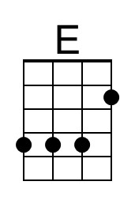
 |  |  |  |  |  |  |  |  | 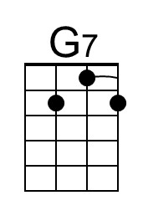
 | 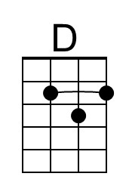 | 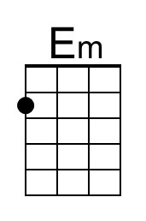 | 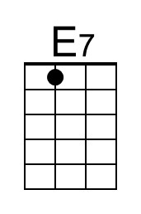 |  | 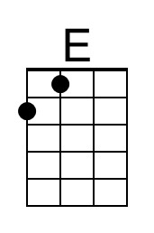 |  | 