Welcome Back (John Sebastian)
G A D 2X

Em
Welcome back -
A D
Your dreams were your ticket out
Em
Welcome back –
A D
To that same old place that you laughed about
F#m B7
Well the names have all changed
Em
Since you hung around
Gm
But those dreams have remained
Dmaj7
And they've turned around
Em
Who'd have thought they'd lead ya
Em7
Who'd have thought they'd lead ya
G
Back here where we need ya
A
Back here where we need ya

Chorus:
G
Yea we tease him a lot
A
‘Cause we got him on the spot
D
Welcome back –
G A D
Welcome back welcome back welcome back
G A D
Welcome back welcome back welcome back

Em
Welcome back
A D
We always could spot a friend
Em
Welcome back
A D
And I smile when I think how it must have been

F#m B7 Em
And i know what a scene you were learnin in
Gm
Was there something
Dmaj7
That made you come back again
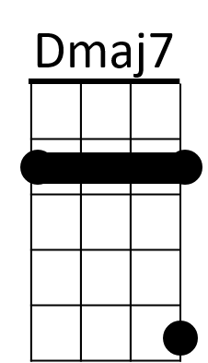
Em
And what could ever lead ya
Em7
What could ever lead ya
G
Here where we need ya
A
Here where we need yea

(Chorus)

F#m B7 Em
And i know what a scene you were learnin in
Gm
Was there something
Dmaj7
That made you come back again
Em
And what could ever lead ya
Em7
What could ever lead ya
BARITONE
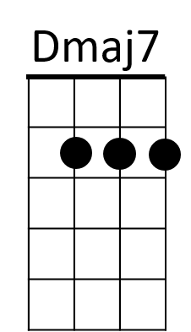
G
Here where we need ya
A
Here where we need yea

(Chorus)

A D
Yea we tease him a lot
G A
Welcome back welcome back
D
Cause we got him on the spot
G A
Welcome back welcome back

(Chorus)

2X
G A D
Welcome back welcome back welcome back

