


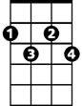



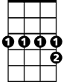
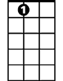
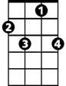
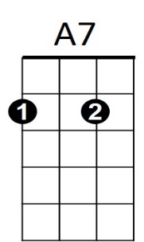
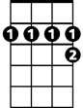
We'll Meet Again (Ross Parker & Hughie Charles, 1939)
Dm
Am
G7
Gdim
D7
F
C
Bb7
E7
C7
A7
C E7 Am Bb7 A7  We'll meet again don't know where, don't know when,  D7 Dm7 G7  But I know we'll meet again some sunny day.  C E7 Am Bb7 A7  Keep smilin' through just like you always do  D7 Dm7 G7 C G7 C  Till the blue skies drive the dark clouds far a-way.  (Tacet) C7  So will you please say hello to the folks that I know.  F  Tell them I won't be long  D7  They'll be happy to know that as you saw me go  G7 Dm7 G7  I was singing this song.  C E7 Am Bb7 A7  We'll meet again don't know where, don't know when,  D7 Dm7 G7 C G7  But I know we'll meet a-gain some sunny day.  Repeat from top.  Outro (retard last line)  C E7 Am Bb7 - A7  We'll meet again don't know where, don't know when,  D7 Dm7 G7 C F G7 C  But I know we'll meet again some sunny day. | 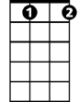  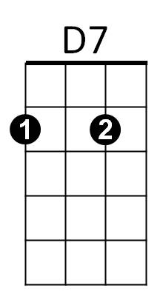      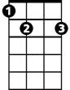  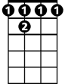  C7  F  Gdim  Dm  G7  A7  Am  C  E7  Bb7
Bari

