We'll Meet Again (Ross Parker & Hughie Charles, 1939)
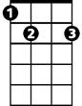
C E7 Am Bb7 A7
E7
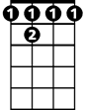

We'll meet again don't know where don't know whe - n
Bb7
C
D7 Am Dm G7
But I know we'll meet again some sunny day
C E7 Am Bb7 A7
Keep smiling through just like you always do - o
D7 Dm G7 C

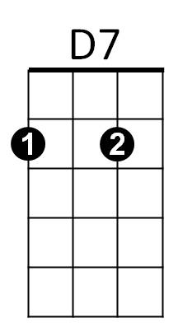

Till the blue skies drive the dark clouds far away
Am
A7

TACET C7
So will you please say hello to the folks that I know
F
Tell them I won't be long



D7
Gdim
G7
Dm
They'll be happy to know that as you saw me go
G7 Gdim G7
I was sing-ing this song

C E7 Am Bb7 A7


We'll meet again don't know where don't know whe - n
F
C7
D7 Am Dm G7 C
But I know we'll meet a - gain some sunny day

Repeat from Beginning
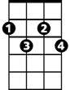
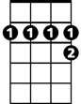
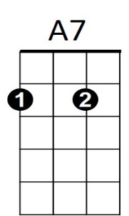
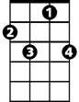


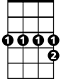
BARITONE
Gdim
A7
C7
F
G7
Dm
Am
D7
E7
Bb7
C

