What Kind of Fool Am I (Leslie Bricusse / Anthony Newley)

G C
What kind of fool am I
Dm G
Who never fell in love
C A7
It seems that I'm the only one
Dm G
That I have been thinking of

C Am
What kind of man is this?
D7
An empty shell

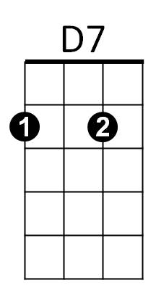

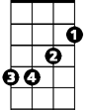
G Em
Am
D
Em
A lonely cell in which
Am D G
An empty heart must dwell

C
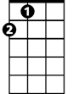


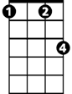
What kind of lips are these
A
F
Gm
Fm
Dm G
That lied with every kiss
C Gm
That whispered empty words of love
A Gm C
That left me alone like this
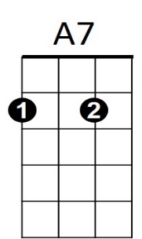
C
Dm

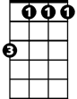
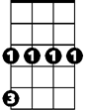



F Fm
BARITONE
G
Fm
Gm
A
Am
D7
Em
D
Why can't I fall in love
C D
Like any other man
Dm
And maybe then I'll know
Fm G C Am F G
What kind of fool I am.

G C
What kind of clown am I?
Dm G

What do I know of life?
F
C Gm A
Why can't I cast away the mask of play
Gm C
And live my life?

F Fm
Why can't I fall in love
C D
Till I don't give a damn
Dm
And maybe then I'll know
Fm G C Am F G Dm C
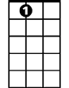
What kind of fool I am.
C
Dm
G
A7

