What's New Pussycat? (Burt Bachrach / Hal David)
Chorus:
C F G



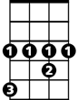


What's new pussycat? W hoa, whoa, whoa, whoa.
C
G
F
Ab
Bb
D
C F G C D
What's new pussycat? Whoa, whoa, whoa, whoa.

G D Bb
Pussycat, Pussycat, I've got flowers,
Ab
And lots of hours to spend with you.
D
So, go and powder your cute little pussycat nose!
G Bm C Bm Am C Bm
Pussycat, Pussycat, I love you. Yes, I do!
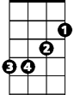

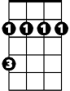
Am D G
Em
Am
Bm
You and your pussycat nose!

(CHORUS)

G D Bb
Pussycat, Pussycat, you're so thrilling,
Ab
and I'm so willing, to care for you.
D
So, go and make up your big little pussycat eyes!
G Bm C Bm Am C Bm
Pussycat, Pussycat, I love you. Yes, I do!
BARITONE
Am D G
C
F
G
You and your pussycat eyes!

(CHORUS)

G D Bb
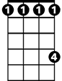
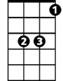
Pussycat, Pussycat, you're delicious,
Ab
Bb
D
Ab
And if my wishes can all come true.
D
I'll soon be kissing your sweet little pussycat lips!
G Bm C Bm Am C Bm

Pussycat, Pussycat, I love you. Yes, I do!
Bm
Am
Em
Am D G Em
You and your pussycat lips! Whoa, whoa!
Am D G Em
You and your pussycat eyes! Whoa, whoa!
Am D G
You..and your..pussycat..no..se!

