When Irish Eyes Are Smiling (Chauncey Olcott, George Graff Jr)

C
There's a tear in your eye, and I'm wondering why
G7 C
For it never should be there at all
G7
With such power in your smile
C A7
Sure a stone you'd bequile
D7 G7
So there's never a teardrop should fall
C
When your sweet lilting laughter's like some fairy song
G7 C C7 F
And your eyes twinkle bright as can be
D7 G

You should laugh all the while and all other times smile
C
D7 G
And now smile a smile for me

Chorus:

C

When Irish eyes are smiling,
G7
F C
Sure tis like a morn in spring
F C A7
In the lilt of Irish laughter
D7 G
You can hear the angels sing
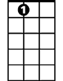
C C7
A7
When Irish hearts are happy
F C
All the world seems bright and gay
F C A7
And when Irish eyes are smil-ing
D7 G7 C
Sure they steal your heart away
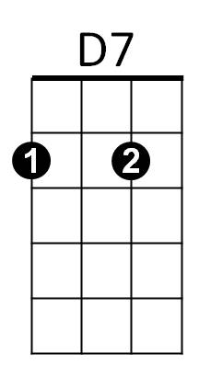



C7
F
G

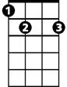
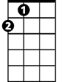
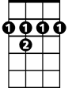

E7
A
B7
D

C
For your smile is a part, of the love in your heart
G7 C
And it makes even sunshine more bright
G7
Like the linnet's sweet song
C A7
Crooning all the day long
D7 G7
Comes your laughter and light
C
For the springtime of life, is the sweetest of all
G7 C
And there is ne'er a real care or regret
G7
BARITONE
And while springtime is ours
C
C A7
Throughout all of youth's hours
D7 G
Let us smile each chance we get

[Chorus]
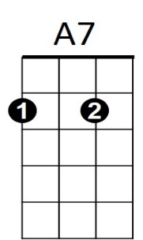
A7 D
When Irish eyes are smiling,
G7
G D
Sure 'tis like a morn in spring
G D B7
In the lilt of Irish laughter
E7 A
You can hear the angels sing
D7
D D7
When Irish hearts are happy
G D
All the world seems bright and gay
G D B7
And when Irish eyes are smil-ing
E7 A7 D
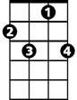

Sure they steal your heart away
D
C7
F
G

E7
A
B7

