When Irish Eyes Are Smiling (Chauncey Olcott, George Graff Jr)

C
There's a tear in your eye, and I'm wondering why
G7
For it never should be there at all
With such power in your smile
C A7
Sure a stone you'd bequile
D7 G
So there's never a teardrop should fall
G7
When your sweet lilting laughter's like some fairy song
C C7 F
And your eyes twinkle bright as can be
D7 G

You should laugh all the while and all other times
C
G7
smile
D7 G G7
And now smile a smile for me

Chorus:

C G C

When Irish eyes are smiling,
G7
F C
Sure tis like a morn in spring
F C A7
In the lilt of Irish laughter
D7 G
You can hear the angels sing
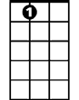
C G C C7
A7
When Irish hearts are happy
F C
All the world seems bright and gay
F C A7
And when Irish eyes are smil-ing
D7 G7 C
Sure they’ll steal your heart away
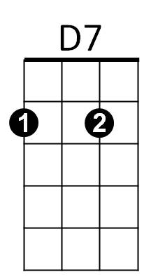



C7
F
G


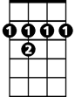
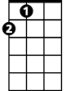
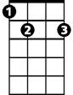
D
B7
A
E7

C
For your smile is a part, of the love in your heart
G7
And it makes even sunshine more bright
Like the linnet's sweet song
C A7
Crooning all the day long
D7 G
Comes your laughter and light
G7
For the springtime of life, is the sweetest of all
C C7 F
And there is ne'er a real care or regret
D7
And while springtime is ours
BARITONE
G G7
Throughout all of youth's hours
C
D7 G G7
Let us smile each chance we get

[Chorus]

A7 D A D
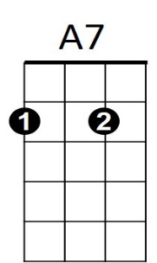
When Irish eyes are smiling,
G D
Sure 'tis like a morn in spring
G D B7
In the lilt of Irish laughter
E7 A
You can hear the angels sing
D A D D7
When Irish hearts are happy
G7
G D
All the world seems bright and gay
(2X)
G D B7
And when Irish eyes are smil-ing
E7 A7 D
Sure they’ll steal your heart away

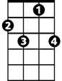
A
B7
E7
D
G
F
C7
D7

