




When the Saints Go Marching In (Of uncertain origin before 1923) (C)

Intro C G7 C  C  Oh, when the saints go marching in  G7  Oh, when the saints go marching in  C C7 F  Oh Lord, I want to be in that number  C G7 C  When the saints go marching in  C  Oh, when the trumpet sounds the call  G7  Oh, when the trumpet sounds the call  C C7 F  Oh Lord, I want to be in that number  C G7 C  When the trumpet sounds the call  C  Oh, when the band begins to play  G7  Oh, when the band begins to play  C C7 F  Oh Lord, I want to be in that number  C G7 C  When the band begins to play  C  Oh, when the stars fall from the sky  G7  Oh, when the stars fall from the sky  C C7 F  Oh Lord, I want to be in that number  C G7 C  When the stars fall from the sky |  |  |  |  | C  Oh, when the rev-elation comes  G7  Oh, when the revelation comes  C C7 F  Oh Lord, I want to be in that number  C G7 C  When the revelation comes  C  Oh, when the sun begins to shine  G7  Oh, when the sun begins to shine  C C7 F  Oh Lord, I want to be in that number  C G7 C  When the sun begins to shine  C  Oh, on that hal-lelujah day  G7  Oh, on that hallelujah day  C C7 F  Oh Lord, I want to be in that number  C G7 C  On that hallelujah day  C  Yes, when the saints go marching in  G7  Yes, when the saints go marching in  C C7 F  Yes Lord, I want to be in that number  C G7 C  When the saints go marching in  Halla lu-uuu ja
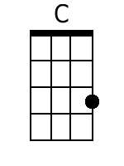 | 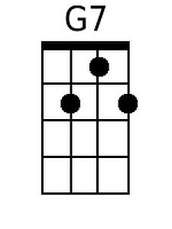 | 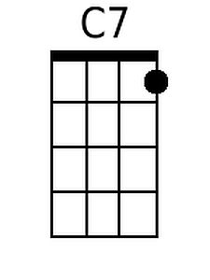 | 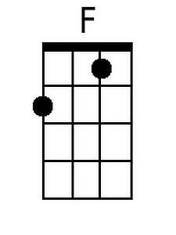 | Bari |  | 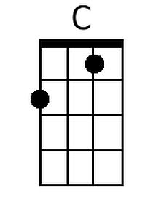 | 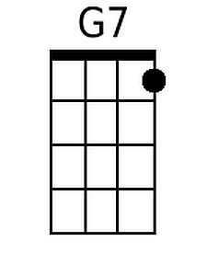 | 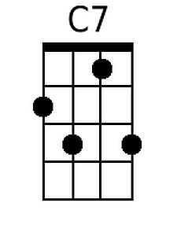 | 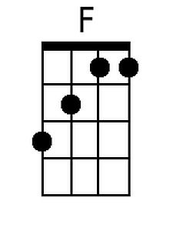


When the Saints Go Marching In (Of uncertain origin before 1923) (G)

Intro G D7 G  G  Oh, when the saints go marching in  D7  Oh, when the saints go marching in  G G7 C  Oh Lord, I want to be in that number  G D7 G  When the saints go marching in  G  Oh, when the trumpet sounds the call  D7  Oh, when the trumpet sounds the call  G G7 C  Oh Lord, I want to be in that number  G D7 G  When the trumpet sounds the call  G  Oh, when the band begins to play  D7  Oh, when the band begins to play  G G7 C  Oh Lord, I want to be in that number  G D7 G  When the band begins to play  G  Oh, when the stars fall from the sky  D7  Oh, when the stars fall from the sky  G G7 C  Oh Lord, I want to be in that num ber  G D7 G  When the stars fall from the sky |  |  |  |  | G  Oh, when the rev-elation comes  D7  Oh, when the revelation comes  G G7 C  Oh Lord, I want to be in that number  G D7 G  When the revelation comes  G  Oh, when the sun begins to shine  D7  Oh, when the sun begins to shine  G G7 C  Oh Lord, I want to be in that number  G D7 G  When the sun begins to shine  G  Oh, on that hal-lelujah day  D7  Oh, on that hallelujah day  G G7 C  Oh Lord, I want to be in that number  G D7 G  On that hallelujah day  G  Yes, when the saints go marching in  D7  Yes, when the saints go marching in  G G7 C  Yes Lord, I want to be in that number  G D7 G  When the saints go marching in  Halla lu-uuu ja
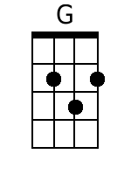 | 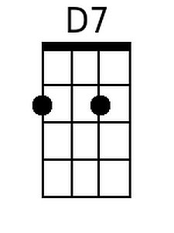 |  |  | Bari |  | 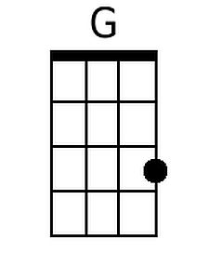 | 