White Rabbit (Gracie Slick) Key B
Intro: B

B
One pill makes you larger,
C
and one pill makes you small
B
And the ones that mother gives you,
C
Don’t do anything at all
D F D
Go ask Alice, when she's ten feet tall

B
And if you go chasing rabbits,
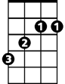



C
B
F
D
C
And you know you're going to fall
B
Tell 'em a hookah-smoking caterpillar
C

Has given you the call
C
3
D F D
And call Alice, when she was just small

A
When the men on the chessboard
D
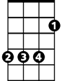

Get up and tell you where to go
B
A
C
D
F
A
BARITONE
And you've just had some kind of mushroom,
D
And your mind is moving low
B
Go ask Alice, I think she'll know

B
When logic and proportion
C
Have fallen sloppy dead
B
And the white knight is talking backwards
C
And the red queen's off with her head
D F D
Remember what the door mouse said
A D A D
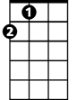
Feed your head, feed your head
F
8
D
5
A

