White Rabbit (Gracie Slick) Key B
Intro: B

B
One pill makes you larger,
C
and one pill makes you small
B
And the ones that mother gives you,
C
Don’t do anything at all
D F G D
Go ask Alice, when she's ten feet tall

B
And if you go chasing rabbits,
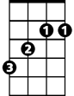



C
B
F
D
C
And you know you're going to fall
B
Tell 'em a hookah-smoking caterpillar
C
Has given you the call

D F G D
C
3
And call Alice, when she was just small

A
When the men on the chessboard
D
Get up and tell you where to go
BARITONE
A
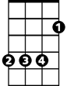
A
B
And you've just had some kind of mushroom,
D
And your mind is moving low
B
Go ask Alice, I think she'll know
C
3

B
When logic and proportion
C
Have fallen sloppy dead
B
And the white knight is talking backwards
C
And the red queen's off with her head
D F G D
Remember what the door mouse said
A D A D
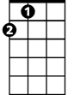
Feed your head, feed your head
A


G
D
5
F
8

F
D
C

G
G
3
D
5
F
9

