Who Threw the Overalls in Mrs. Murphy’s Chowder? (George L. Giefer / Mat Ray) Key C


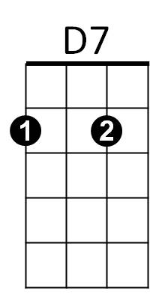
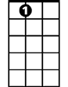

C
G7
A7
C
The Murphy's gave a party
Just about a week ago
Am
Everything was plentiful,
D7 G7
The Murphy's they're not slow
C
They treated us like gentlemen,
We tried to act the same
D7
But only for what happened,
G D7 G
Well, it was an awful shame
F G7


When Mrs. Murphy dished the chowder out
F
G
C
She fainted on the spot
F G7
She found a pair of overalls
C
In the bottom of the pot
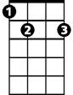

Tim Nolan he got rippin' mad
E7
Am
His eyes were bulgin' out
D7
He jumped up on the PI-A-NO
G D7 G
And loudly he did shout -

Chorus:
C
Oh, who threw the overalls
BARITONE
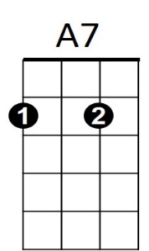



In Mrs. Murphy's chowder?
D7
C
G
Am
F
G7
E7
D7 G7
Nobody spoke, so he shouted all the louder
C E7 Am
It's an Irish trick that's true
F C
I can lick the cur that threw
D7 G7 C
The overalls in Mrs Murphy's chow - der

C
We dragged the pants from out the soup
And laid them on the floor
Am
Each man swore upon his life
D7 G7
He’d ne'er seen them before
C
They were plastered up with mortar
And were worn out at the knee
D7
They'd had their many ups and downs
G D7 G
As we could plainly see

F G7
When Mrs. Murphy she came to
C
She began to cry and pout
F G7
She'd had them in the wash that day
C
And forgot to take them out
Tim Nolan he excused himself
For what he'd said that night
D7
So we put music to the words
G D7 G
And sang with all our might

(Chorus)

Who Threw the Overalls in Mrs. Murphy’s Chowder? (George L. Giefer / Mat Ray) Key G

G
G
A7
E7
The Murphy's gave a party
Just about a week ago
Everything was plentiful,
A7 D7
The Murphy's they're not slow
G
They treated us like gentlemen,
We tried to act the same
A7
But only for what happened,
D A7 D
Well, it was an awful shame
C D7

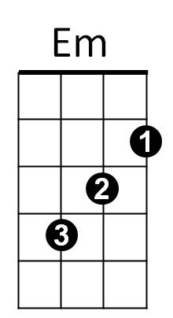
When Mrs. Murphy dished the chowder out
D
C
G
She fainted on the spot
C D7
She found a pair of overalls
G
In the bottom of the pot
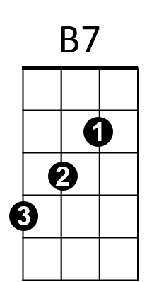
Tim Nolan he got rippin' mad
His eyes were bulgin' out
A7
He jumped up on the PI-A-NO
D A7 D
And loudly he did shout -

Chorus:
G
Oh, who threw the overalls
BARITONE
In Mrs Murphy's chowder?
A7 D7
Nobody spoke, so he shouted all the louder
G B7 Em
It's an Irish trick that's true
C G
I can lick the cur that threw
A7 D7 G
The overalls in Mrs Murphy's chow - der

G
We dragged the pants from out the soup
And laid them on the floor
Each man swore upon his life
A7 D7
He’d ne'er seen them before
G
They were plastered up with mortar
And were worn out at the knee
A7
They'd had their many ups and downs
D A7 D
As we could plainly see

C D7
When Mrs Murphy she came to
G
She began to cry and pout
C D7
She'd had them in the wash that day
G
And forgot to take them out
Tim Nolan he excused himself
For what he'd said that night
A7
So we put music to the words
D A7 D
And sang with all our might

(Chorus)

D
E7
G
D7
C
Em
B7

Who Threw the Overalls in Mrs. Murphy’s Chowder? (George L. Giefer / Mat Ray) Key D
D

D
The Murphy's gave a party j
Just about a week ago
Everything was plentiful,
E7 A7
The Murphy's they're not slow
D
A7
E7
They treated us like gentlemen,
We tried to act the same
E7
But only for what happened,
A E7 A
Well, it was an awful shame
G A7
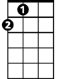
When Mrs. Murphy dished the chowder out
A
G
D
She fainted on the spot
G A7
She found a pair of overalls
D
In the bottom of the pot
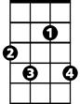
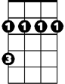
Tim Nolan he got rippin' mad
F#7
Bm
His eyes were bulgin' out
E7
He jumped up on the PI-A-NO
A E7 A
And loudly he did shout -

Chorus:
D
Oh, who threw the overalls
BARITONE
In Mrs Murphy's chowder?
D
E7 A7
Nobody spoke, so he shouted all the louder
D F#7 Bm
It's an Irish trick that's true
G D
I can lick the mick that threw
A
E7 A7 D
The overalls in Mrs Murphy's chow - der

D
We dragged the pants from out the soup
And laid them on the floor
Each man swore upon his life
E7 A7
He’d ne'er seen them before
D
They were plastered up with mortar
And were worn out at the knee
E7
They'd had their many ups and downs
A E7 A
As we could plainly see

G A7
When Mrs Murphy she came to
D
She began to cry and pout
G A7
She'd had them in the wash that day
D
And forgot to take them out
Tim Nolan he excused himself
For what he'd said that night
E7
So we put music to the words
A E7 A
And sang with all our might

(Chorus)

E7
B7

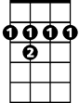
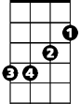
F#7
Bm
G

