Wichita Lineman (Jimmy Webb)
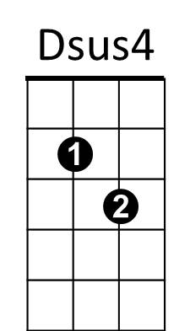

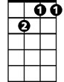
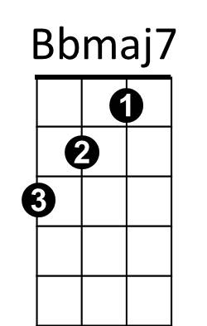





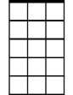
Intro: F Gm7 F
F
Gm7
D
G
Dm
Bb
Gm
Am7
Gm7 Bbmaj7
I am a lineman for the county
F Gm7
And I drive the main road
Dm Am7 G D Dsus4 D
Searchin' in the sun for another overload.

Am7
I hear you s ingin' in the wires,
G Gm
I can hear you through the whine
D Am7 Bb
And the Wichita Lineman is still on the line.

Bb Am7 / Bb Gm7

Gm7 Bbmaj7
I know I need a small vacation,
BARITONE
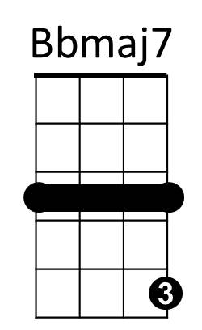
F Gm7
F
Dm
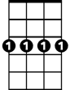
But it don't look like rain.
Gm7
Dm Am7
And if it snows that stretch down south
G D Dsus4 D
Won’t ever stand the strain.

D
G
Am7
And I need you more than want you,
G Gm
And I want you for all time.
D Am7 Bb Am7 Bb Gm7
And the Wichita Lineman is still on the line.
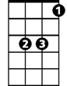
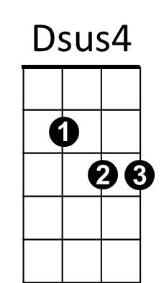
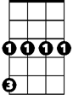
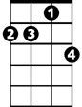
Bb
Gm
Am7
(Instrumental verse)
Am7
And I need you more than want you,
G Gm
And I want you for all time.
D Am7 Bb Am7
And the Wichita Lineman is still on the line.

Bb Am7 (Repeat to fade)

