Winchester Cathedral (Geoff Stephens)

Intro: C G G7 C





G7
C
G
C7
F
C G
Winchester Cathedral, you're bringing me down.
G7 C
You stood and you watched as, my baby left town.
C G
You could have done something, but you didn't try.
G7 C
You didn't do nothing; you let her walk by.


Bridge:
D
C C7 F
Now everyone knows just how much I needed that gal,
D D7
She wouldn't have gone far a-way.
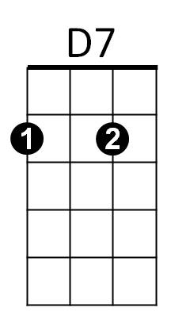
G D7 G7
If only you'd started ringing your bell.

C G
Winchester Cathedral, you're bringing me down.
G7 C
You stood and you watched as, my baby left town.


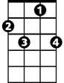
(Instrumental Verse) (kazoos?)
F
G
BARITONE
C
G7
C7
D
D7

Outro:

C G
Oh-bo-de-o-do, oh-bo-de-o-do,
G7 C
Oh-bo-de-o-do de-do-duh.

