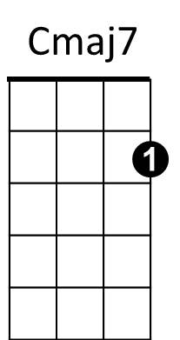
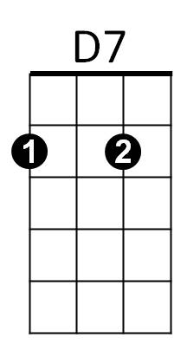
Windmills of Your Mind (Marilyn Bergman / Michel Legrand / Alan Bergman) Key Em
Intro: Em B7 Em GCEA
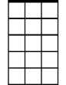
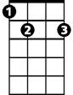
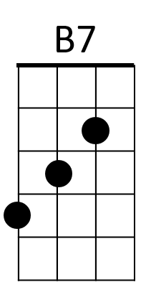
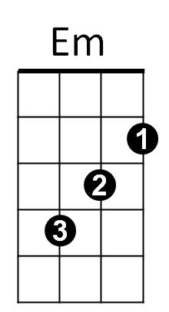
Am7
E7

Em
Round, like a circle in a spiral,
B7
Like a wheel within a wheel
Never ending or beginning
Em
On an ever spinning reel
E7
Like a snowball down a mountain,
Am7
Or a carnival balloon
D7
Like a carousel that's turning,
Gmaj7
Running rings around the moon

Chorus:
Cmaj7
Like a clock whose hands are sweeping
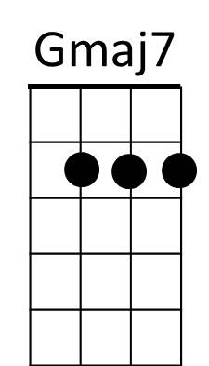
Am
Past the minutes of its face
B7
And the world is like an apple
Em
Whirling silently in space
Bbdim B7

Like the circles that you find
Am
Em
In the windmills of your mind!

Em
Like a tunnel that you follow
B7

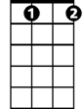
To a tunnel of its own
G7
Bbdim
Down a hollow to a cavern
Em
Where the sun has never shone
E7
Like a door that keeps revolving
Am7
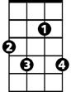
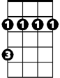
In a half forgotten dream
F#7
Bm
D7
Or the ripples from a pebble
Gmaj7
Someone tosses in a stream

(Chorus)
Em
Keys that jingle in your pocket,
Am7
Words that jangle in your head
D7
Why did summer go so quickly,
Gmaj7
Was it something that you said?
G7
Lovers walking along a shore
Cmaj7
And leave their footprints in the sand
F#7
Is the sound of distant drumming
Bm
Just the fingers of your hand?
E7
Pictures hanging in a hallway
Am
And the fragment of a song
D7
Half remembered names and faces,
Gmaj7
But to whom do they belong?
Cmaj7
When you knew that it was over
Am
You were suddenly aware
B7
That the autumn leaves were turning
Em
To the color of her hair!

Em
Like a circle in a spiral,
B7
Like a wheel within a wheel
Never ending or beginning
Bbdim
On an ever spinning reel
Em
As the images unwind,
B7
Like the circles that you find
Em
In the windmills of your mind!

Windmills of Your Mind (Marilyn Bergman / Michel Legrand / Alan Bergman) Key Em DGBE
BARITONE
Intro: Em B7 Em
Em
B7

Em
Round, like a circle in a spiral,
B7
Like a wheel within a wheel
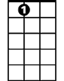
Never ending or beginning
E7
Em
On an ever spinning reel
E7
Like a snowball down a mountain,
Am7
Or a carnival balloon
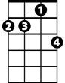
D7
Am7
Like a carousel that's turning,
Gmaj7
Running rings around the moon

Chorus:
Cmaj7
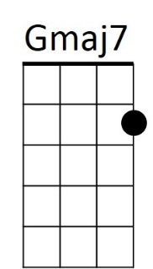
Like a clock whose hands are sweeping
D7
Am
Past the minutes of its face
B7
And the world is like an apple
Em
Whirling silently in space

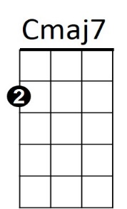
Bbdim B7
Am
Like the circles that you find
Em
In the windmills of your mind!

Em
Like a tunnel that you follow

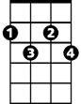
B7
G7
Bbdim
To a tunnel of its own
Down a hollow to a cavern
Em
Where the sun has never shone
E7
Like a door that keeps revolving
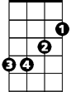
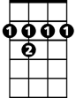
Am7
Bm
F#7
In a half forgotten dream
D7
Or the ripples from a pebble
Gmaj7
Someone tosses in a stream

(Chorus)
Em
Keys that jingle in your pocket,
Am7
Words that jangle in your head
D7
Why did summer go so quickly,
Gmaj7
Was it something that you said?
G7
Lovers walking along a shore
Cmaj7
And leave their footprints in the sand
F#7
Is the sound of distant drumming
Bm
Just the fingers of your hand?
E7
Pictures hanging in a hallway
Am
And the fragment of a song
D7
Half remembered names and faces,
Gmaj7
But to whom do they belong?
Cmaj7
When you knew that it was over
Am
You were suddenly aware
B7
That the autumn leaves were turning
Em
To the color of her hair!

Em
Like a circle in a spiral,
B7
Like a wheel within a wheel
Never ending or beginning
Bbdim
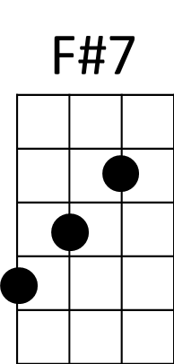
On an ever spinning reel
Em
As the images unwind,
B7
Like the circles that you find
Em
In the windmills of your mind!

