Wind Beneath My Wings (Jeff Silbar / Larry Henley) Key C





C F
Dm
G
C
F
It must have been cold there in my shadow,
C F
To never have sunlight on your face.
Dm G
You were content to let me shine; that's your way.
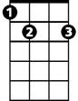

Dm G
E7
Am
You always walked a step behind.

C F
So I was the one with all the glory,
C F
While you were the one wi th all the strain.
Dm G
A beautiful face without a name; for so long.
Dm G E7


A beautiful smile to hide the pain.
Dm
C
F
BARITONE

Chorus:
Am F C
Did you ever know that you're my hero,
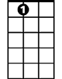
Am F C G
Am
E7
And everything I would like to be?
G
Am F C G
I can fly higher than an ea-gle
F G C
For you are the wind beneath my wings.

C F
It might have appeared to go unnoticed,
C F
But I've got it all here in my heart.
Dm G
I want you to know I know the truth, of course I know it.
Dm G E7
I would be nothing without you.

(Chorus) 2x

Wind Beneath My Wings (Jeff Silbar / Larry Henley) Key G

G C
Am
C
G
It must have been cold there in my shadow,
G C
To never have sunlight on your face.
Am D
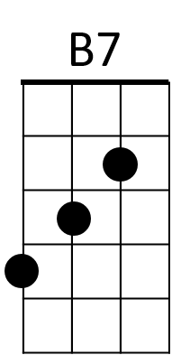

You were content to let me shine; that's your way.
D
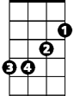
Am D
Em
You always walked a step behind.

G C
So I was the one with all the glory,
G C
While you were the one with all the strain.
Am D
A beautiful face without a name; for so long.
Am D B7
A beautiful smile to hide the pain.
Am
G
C
BARITONE
Chorus:
Em C G
Did you ever know that you're my hero,
Em C G D
And everything I would like to be?
D
Em
B7
Em C G D
I can fly higher than an ea-gle
C D G
For you are the wind beneath my wings.

G C
It might have appeared to go unnoticed,
G C
But I've got it all here in my heart.
Am D
I want you to know I know the truth, of course I know it.
Am D B7
I would be nothing without you.

(Chorus) 2x

