Witchy Woman (Eagles) UBA
Intro: Dm / Dm/ C/Am/Am/ C/A7/ A7/ C / Dm/ Dm/



C
Dm
Dm A7 Dm
Raven hair and ruby lips, Sparks fly from her finger tips,
A7 Dm
Echoed voices in the night, She's a restless spirit on and endless flight


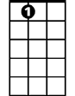
Chorus:
Am
A7
Dm A7 Dm
Woohoo witchy woman, See how high she fli-ies
Dm A7 Dm
Woohoo witchy woman, She got the moon in her eye-es


(Intro)
Gm

Dm A7 Dm
She had me spellbound in the night. Dancing shadows in the fire light
A7
Crazy laughter in another room,
Dm
And she drove herself to madness with a silver spoon.

(Chorus)

Dm / Dm/ C/Am/Am/ C/A7/A7/ C/Dm/Dm/ Dm/ Dm/ C/Am /Am/ C/A7/A7/ C/ Dm/Dm/
Ah - ah – ah ah ah – Ah - ah – ah ah ah

Dm Am A7 Dm Dm Am A7 Dm Dm Dm/ Dm/ C/Am/Am/ C/A7/A7/ C/Dm/Dm/


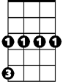
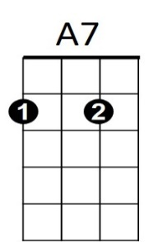
Dm
Am
BARITONE
C
Dm
Gm
I know you want to love her, but let me tell you brother,
Gm A7 Dm
She's been sleepin’ in the devil's bed.
Dm
There's some rumors goin round, someone's underground,
Gm A7 Dm
She can rock you in the night until your skin turns red

(Chorus)

Intro 2x (slowing at end)

