Wouldn’t It Be Loverly (Alan Jay Lerner / Frederick Loewe)


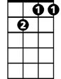


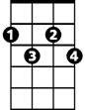
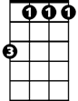
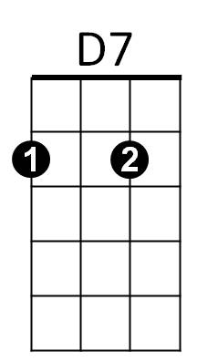
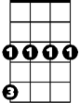



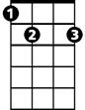
F
Bb
Gm7
C7
G7
Cdim
Bbm
Cm
G
Am
Dm
E7
F Bb Gm7 C7
All I want is a room somewhere
F G7 C7
Far away from the cold night air
F C7 Cm D7
With one enormous chair
Bbm F Cdim Gm7 C7
Oh, wouldn't it be loverly?

F Bb Gm7 C7
Lots of chocolate for me to eat
F G7 C7
Lots of coal making lots of heat
F C7 Cm D7
Warm face warm hands warm feet
Bbm F C7 F
Oh, wouldn't it be loverly?

C G7 C E7 Am E C7
Oh so loverly sitting absobloomin’ lute - ly still
Dm E7 Am E7 Am D7 G Gm7 C7
I would nev - er budge til spring crept over the windowsill

F Bb G m7 C7
BARITONE
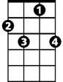
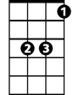
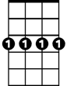
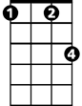
Someone's head resting on my knee
C7
G7
F
Bb
Gm7
Cm
F G7 C7
Warm and tender as he can be
F C7 Cm D7
Who takes good care of me
Bbm F Dm Gm7 C7 F C7 Bb
Oh, wouldn't it - be loverly? Loverly, loverly?

(Repeat song)

Bbm F Dm Gm7 C7 F
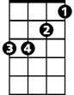


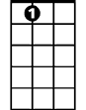
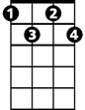
Loverly Oh, wouldn't it - be loverly?
Bbm
G
Am
Dm
E7
Cdim
D7

