Yankee Doodle Boy ("Yankee Doodle Dandy") Key C
(George M. Cohan / Kenneth Elkinson)


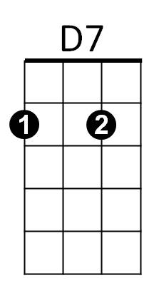

C D7
G7
C
I'm a Yankee Doodle Dandy
G7 C
A Yankee Doodle, do or die
A7 Dm
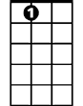

A real live ne phew of my Uncle Sam
A7
Dm
D7 G G7
Bor n on the Fourth of July
C D7
I've got a Yankee Doodle sweetheart
G7 C
She's my Yankee Doodle joy
C G7 C G7
Yankee Doodle came to London
C G7 C G7
Just to ride the po-nies
D7 G7 C
I am the Yankee Doodle boy

REPEAT SONG

BARITONE

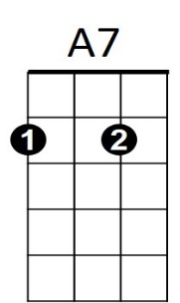


Dm
G7
D7
C

Yankee Doodle Boy ("Yankee Doodle Dandy") Key G
(George M. Cohan / Kenneth Elkinson)

G A7

I'm a Yankee Doodle Dandy
A7
G
D7 G
A Yankee Doodle, do or die
E7 Am
A real live nephew of my Uncle Sam
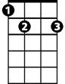

A7 D D7
E7
Am
Born on the Fourth of July
G A7
I've got a Yankee Doodle sweetheart
D7 G
She's my Yankee Doodle joy
G D7 G D7
Yankee Doodle came to London
G D7 G D7
Just to ride the po-nies
A7 D7 G
I am the Yankee Doodle boy

REPEAT SONG
E7
Am
D7
G
BARITONE

