You Are the Sunshine of My Life (Stevie Wonder)
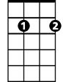



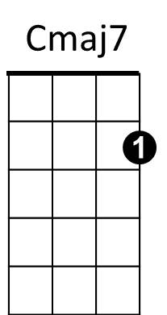
Intro: Cm aj7 G7 x2
Em7
Dm
C
G7

C Dm G Em7 Bbdim
You are the sunshine of my life
Dm G7 C Dm G7
That's why I'll always be around

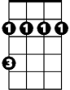
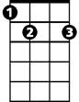
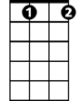

C Dm G Em7 Bbdim
F
Bm
E7
Bbdim
G
You are the apple of my eye
Dm G7 C Dm G7
F#m
B7
Fdim
Forever you'll stay in my heart

C F Cmaj7 F G7

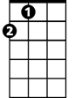

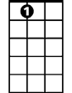
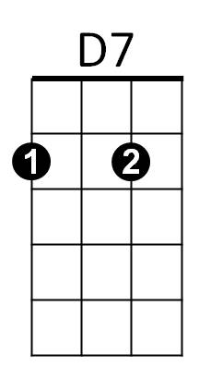
I feel like this is the beginning
Am
A
D
A7
Cmaj7 F Bm E7
Though I've loved you for a million years
A D Em7
And if I thought our love was ending
A7 D7
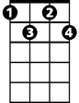
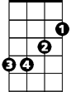
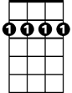
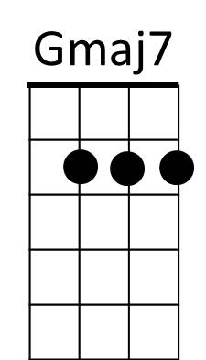
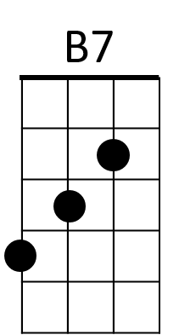
I'd find myself drowning in my own tears
Fdim
Em
Bm7
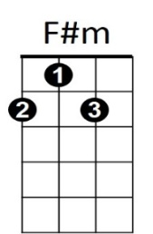
G Am D Bm7 Fdim
You are the sunshine of my life
Am D7 G Am D7
That's why I'll always be around
G Am D Bm7 Fdim
You are the apple of my eye
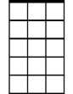
Am D7 G Am D7
BARITONE
Em7
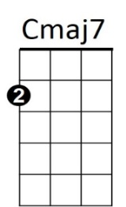


Forever you'll stay in my heart
G7
C
Dm

G C Gmaj7 C D7
You must have known that I was lonely
Gmaj7 C F#m B7
Because you came to my res - cue
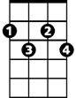

Em A Bm7
Bbdim
G
F
Bm
E7
And I know that this must be heaven
E7 A7 D7
How could so much love be inside of you?

(Repeat to fade)
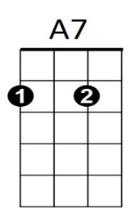
Am
D7
D
A
G Am D Bm7 Fdim
You are the sunshine of my life
Am D7 G Am D7
That's why I'll always be around
G Am D Bm7 Fdim
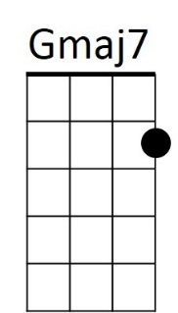
You are the apple of my eye
Bm7
Em
Am D7 G Am D7
Forever you'll stay in my soul

