You Send Me (Sam Cooke)
Intro: C Am Dm G7

C Am Dm G7 C Am Dm G7
Darling you ~ send me, I know you ~ send m e
C Am Dm G7 C
Darling you - send me, honest you do,
Am Dm G7
Honest you do, honest you do, whoa

C Am Dm G7 C Am Dm G7
You ~ thrill me, I know you, you, you thrill me
C Am Dm G7
Darling, you, you, you, you thrill me
C F C
Honest you do

Dm G7 C
At first I thought it was infatuation,
Dm G7 C
But, wooh, it's lasted so long
Dm G7 C Bb A7
Now I find myself wa - nt -ing –
D7 Dm G7
To marry you and take you home, whoa

C Am Dm G7 C Am Dm G7
You, you, you, you send me, I know you ~ send me
C Am Dm G7 C F C
I know you ~ send me ~ Honest you do

C Am Dm G7
You ~ send me ~
Whoa-oh-oh, whenever I'm with you
C Am Dm G7
You ~ send me
I know, I know, I know when I'm near you
C Am Dm G7
You ~ send me
Mm hmm, mmm hmm,
C Am
Honest you do, honest you do
Dm G7
Whoa-oh-oh, I know-oh-oh-oh

C Am Dm G7
You ~ send me
I know, I know, I know, when you hold me
C Am Dm G7
You ~ send me
Whoa, whenever you kiss me
C Am Dm G7
You ~ send me
Mm hmm, mm hmm,
C F C
Honest you do, honest you do
Dm G7 C
At first I thought it was infatuation,
Dm G7 C
But, wooh, it's lasted so long
Dm G7 C Bb A7
Now I find myself wa - nt -ing –
D7 Dm
To marry you and take you home
G7
I know, I know, I know

C Am Dm G7 C Am Dm G7
You ~ send me - I know you - send me
C Am Dm G7
Whoa, you, you, you, you send me
C D G
Honest you do

D Bm7 Em7 A7 D Bm7 Em7 A7
You ~ send me, I know you ~ send me,
D Bm7 Em7 A7
I know you ~ send me,
D G D Db6 Bm7
Honest you do, honest you do, honest you do

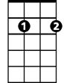
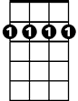
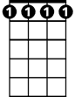
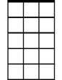
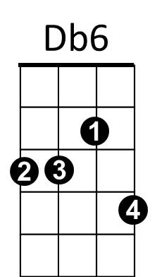
BARITONE
Em7
Bm7
Db6
Em7
Bm7

