You Were On My Mind (Ian and Sylvia)

TACET C F G C F G
When I woke up this morning, you were on my mind..
F Em Dm G
And, you were on my mind.
C F C F
I got troubles, whoa-oh..I got worries, whoa-oh..
Am Dm G
I got wounds to bi - nd.

G C F C F G
So, I went to the corner, just to ease my pain..
F Em Dm G7
Yeah, just to ease my pain.
C F C F
I got troubles, whoa-oh..I got worries, whoa-oh..
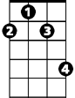

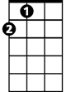

Am G
F#m
D
A
Dm
I came home again.

G C F G C E7 Am G
When I woke up this morning, you were on my mi – i – i - ind..
F Em Dm G
And you were on my mind.
G C F C F
BARITONE
I got troubles, whoa-oh..I got worries, whoa-oh..
C Am D G
I got wounds to bind.

G A D G A D G A
And I got a feelin'..down in my sho-oo-oo-oes, said..
G F#m Em7 A

Way down in my sho-oo-oes.
Dm
D G
Yeah, I got to ramble, whoa-oh..
D G
I got to move on, whoa-oh..
D Bm Em7 A
I got to walk away my blu-ues.
TACET D G A D G A
When I woke up this morning..you were on my mind..
G F#m Em7 A7
You were on my mind.
D G D G
I got troubles, whoa-oh..I got worries, whoa-oh..
D Em7 C A7 D G A D
I got wounds to bi – i - nd.
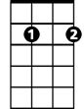





Em7
F
G
Am
G7
C

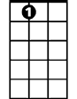
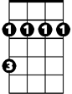
A7
Bm


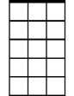

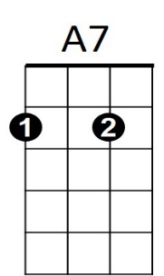
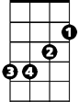
F
C
Em7
G7
Am
G
Bm
D
F#m
A

